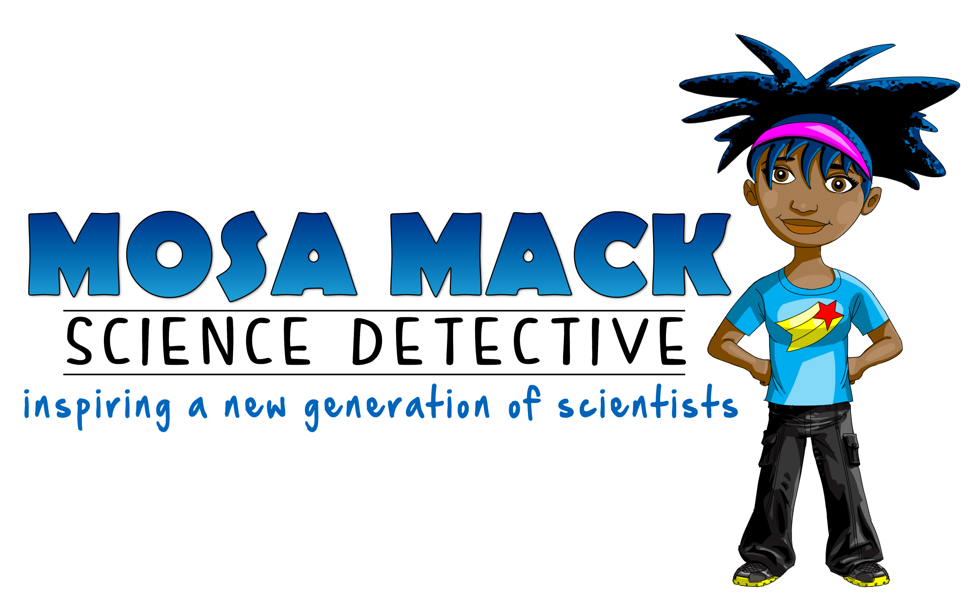
FOR IMMEDIATE RELEASE
OCTOBER 11, 2013

Contact: Katie Timlin
Telephone: 203-213-5355
Email: ktimlin@mosamack.com
Web: www.mosamack.com
Facebook: www.facebook.com/pages/Mosa-Mack-ScienceDetective/553660911319748
Twitter: @mosamack

MEET MOSA MACK:
She’s young, hip, urban – and poised to inspire a whole new generation of scientists.

Mosa Mack (www.mosamack.com) is no ordinary scientist. She and her crew of investigators are young, hip and urban. And on Thursday, October 17th, they’re poised to change the face of science in our children’s classrooms across the country.

Mosa Mack: Science Detective is an animated educational series designed to introduce 4-8th graders to Mosa Mack – a science detective that looks and sounds a lot like them. Utilizing fun characters and a relaxed dialogue, each 6-minute episode explores a scientific mystery and ends with a query the students attempt to solve together. Via the website, teachers can access additional resource materials, such as customizable discussion guides, that coordinate to each episode.

Beginning Monday, October 14th, teachers can preview the pilot episode, “A Growling Hunger”, which explores diabetes, via www.mosamack.com. Three days later, on Thursday, October 17th, 2013, teachers across the country will premiere the first episode to their science classrooms – afterward, sharing the students’ photos and reactions via Twitter and Facebook. Participating classrooms will be entered to win a cash prize of $250.

Mosa Mack: Science Detective is the brainchild of former Harlem science teacher and Discovery Channel/Siemens STEM Institute fellow, Lissa Moses Johnson. Johnson began the project with the hopes of empowering students to see science as fun, accessible and relevant to their young lives. She knew that creating a lead character that looked and sounded like her students could captivate a young audience.
She cautions, however, against the notion that Mosa Mack has a narrow audience. “One common misconception is that our show is only for girls and children of color – but just like a Caucasian male can speak to everyone, so can Mosa Mack. What we’ve seen so far is that all of the students get so drawn into the story that they aren’t even aware that they’re engaging in complex problem-solving exercises.”

# # #

For more information or to schedule an interview with founder, Lissa Moses Johnson, contact Katie Timlin at 203-213-5355 or ktimlin@mosamack.com. For embeddable videos and press-quality images, visit http://www.mosamack.org/#!press/cdkn.

