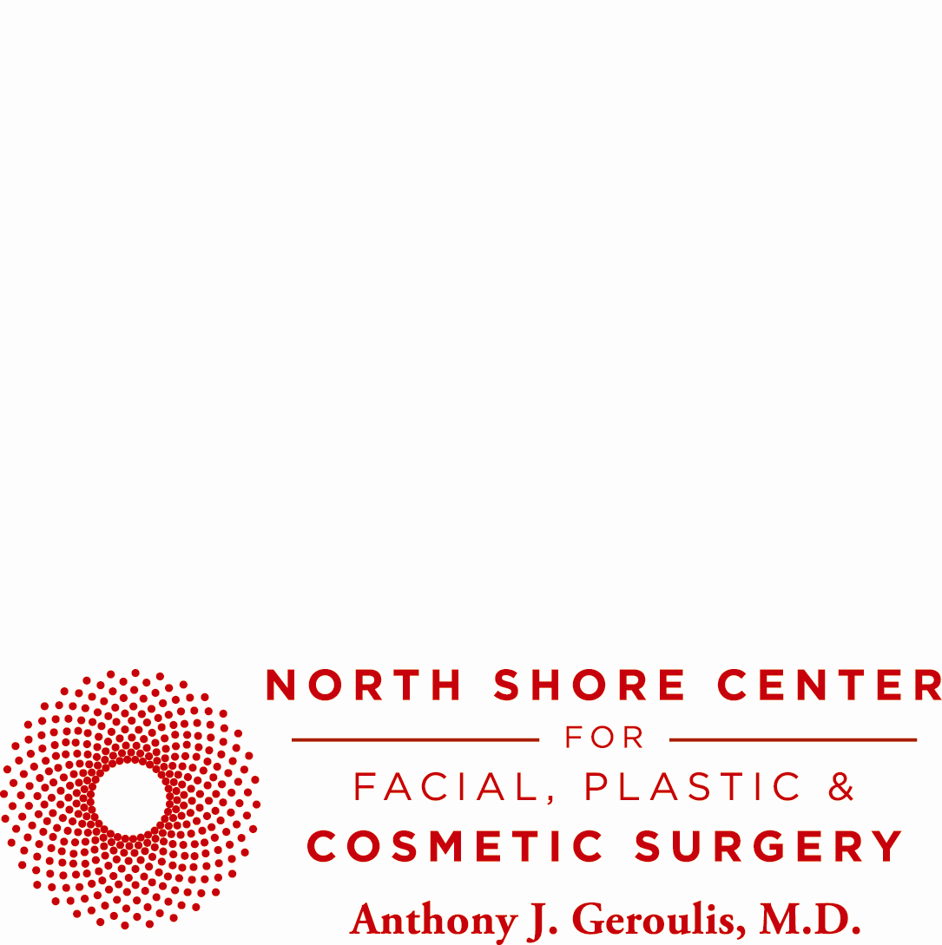
DR. ANTHONY J. GEROULIS APPEARS ON
FOX GOOD DAY CHICAGO TO DISCUSS
THE EAST MIDWEST AND WEST COAST DIVIDE TO ANTI- AGING.

NORTHFIELD, IL—JULY 23, 2013— Board certified cosmetic surgeon and University of Chicago clinical professor of surgery, Dr. Anthony Geroulis is a frequent television guest speaker sharing his opinions on cosmetic surgery. He has appeared on CNN, WGN and most recently, in May 2013, on FOX Good Day Chicago for a discussion of the East, Midwest and West coast divide in surgical procedures in terms of technique and approach.
“It depends […] on the philosophy of the surgeons involved and the preferences of the patients,” explained Dr. Geroulis. “In the Midwest, it’s a more conservative environment here, and as a result […] they want a refreshed look, but they definitely want a natural look. They want to look like themselves but a few years ago.”
Accompanying Dr. Geroulis was recent surgical patient Sandy Hanrahan. The 65-year old retired Midwest nurse underwent a face and neck lift with facial liposuction, in addition to upper and lower eye surgery, just five short weeks before appearing on Good Day Chicago.
The morning talk show, hosted by Ann Davlantes, included the staggering before and after photos of Hanrahan, who spoke about her experience: “I wanted to look like me. […] I didn’t want to be tight. I wanted to look natural. I wanted to look refreshed. I wanted to feel like I did, maybe 20 years ago. […] I’m myself again. I’m happy; I’m outgoing.”
The segment concluded with a discussion of the knife vs. needle approach. Dr. Geroulis noted that while surgical results last much longer, injections can be a remarkable temporary alternative, for those that do not wish to undergo surgery, but only if performed correctly by an experienced physician.
“Well there you see now, being active in the medical industry, the battle between the knife and the needle. It’s as simple as that.”
For more information or to schedule a consultation with Dr. Geroulis, please call (847) 441-4441 or visit www.geroulis.com.
About Dr. Anthony J. Geroulis:
Bringing over 33 years of surgical experience to the field of facial plastic & cosmetic surgery, Anthony J. Geroulis, MD, FICS, was recently named a “Top Doctor” by U.S. News & World Report. Board certified in cosmetic surgery, author and sculptor, Dr. Anthony Geroulis is a clinical professor of surgery at the University of Chicago Medical Center (UCMC). His practice is headquartered in Northfield, with offices on Michigan Avenue in Chicago, at the University of Chicago Medical Center and at St. Alexis Medical Center in Hoffman Estates.

PR Contact:
Madelaine Kukanza
(847) 441-4441
madelaine@geroulis.com

