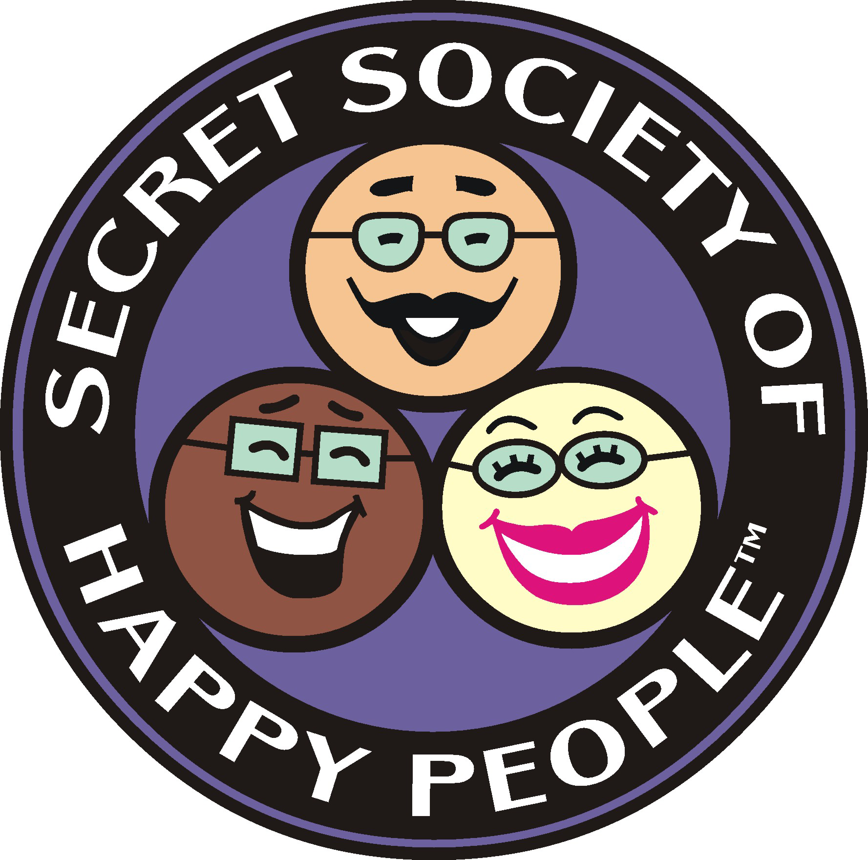
Contact:
Pamela Gail Johnson
972-459-7031 / 469-358-3914
pamelagail@sohp.com

For Release:
Immediate

The Secret Society of Happy People’s
5 Ways to Simplify Your Holidays FREE Video Series
Helps Reduce Holiday Stress

(Dallas, TX) – Does thinking about the holiday to do list cause stress instead of happiness? The Secret Society of Happy People wants to reduce some of the stress and increase the holiday happy with our new free video series, “5 Ways to Simplify Your Holidays.”

The holiday season begins with Halloween and goes through New Year’s Day. This series covers the entire holiday season: Halloween, Thanksgiving, Hanukkah, Christmas Eve, Christmas, New Year’s Eve and New Year’s Day.

Everyone wants to have an idealistic holiday but the reality is all holidays have an element of chaos. It’s part of what makes them fun. But if we can reduce and minimize some of the known chaos, we can enjoy more of the fun chaos not the stress inducing kind.

“The goal of this series is to help people just have more fun during the holidays because they planned ahead enough to get some of the known holiday to-do’s off their list sooner than later,” says Society Founder Pamela Gail Johnson. “The holidays are meant to be enjoyed with our friends and family.”

This free 5-part video series includes a corresponding worksheet to help everyone get organized so when the holidays arrive, you can enjoy more time with friends, family and holiday cheer. The topics to be discussed include:

- Calendars and Essential Supplies
- Gift Suggestions
- Food and Decorations
- Holiday Greetings
- Wrap It Up
- Gift Wrapping Option

Anyone can sign up to get 5 Ways to Simplify Your Holidays at the Secret Society of Happy People’s website: www.sohp.com.

###

Secret Society of Happy People Highlights

Founded: August 1998
Purpose: The Secret Society of Happy People encourages the expression of happiness and discourages parade-raining. Parade-rainers are those people who don't want to hear your happy news. And no, we don't tell people to be happy if they aren't or how to be happy.
Creed: As a member of the Secret Society of Happy People I will:

Recognize happiness with the same enthusiasm as I do unhappiness,
Encourage others to share their happiness,
Don’t unnecessarily rain on other people’s parades.

Members: Thousands from around the world in more than 34 countries

History: The Society gained international recognition in December 1998 when it challenged Ann Landers for discouraging people from writing happy holiday newsletters to enclose with their holiday cards.

Since then the Society has:

- Announced the Happiest Events and Moments of 1998-2012
- Identified the Thirty-One Types of Happiness
- Declared August and August 8th as Happiness Happens Month & Day
Nineteen governors sent proclamations in 1999
- Organized HappyThon, the first online social media event to promote happiness
- Organized voting for the Happiest Events, Inventions and Social Changes of the Century
- Host Hunt for Happiness Week the 3rd Week of January
Seven governors sent proclamations in 2006

The Society is included in Wikepedia and has been featured in People Magazine, Newsweek and Time, and has been included in stories in Reader’s Digest, Prevention, Ladies Home Journal, Harpers, Yoga Journal, SELF, Redbook, Glamour, and New Age Journal. Founder Pamela Gail Johnson was on Politically Incorrect with Bill Maher.

Hundreds of print and broadcast outlets throughout the world have covered the Society, including CNN, The Associated Press, USA Today, Good Morning America (ABC), The Wall Street Journal, The Washington Post, The Dallas Morning News, The Fort Worth Star-Telegram, and Los Angeles Times. Parade named the Happiest Events, Inventions and Social Changes of the Century as the “Best List of the Century.”

A few websites that have linked to the Society include: Beliefnet.com, Good Housekeeping, DailyInBox.com, and USA Today.com Hot Site.

The Society has been included in Think You’re the Only One?, 365 Health and Happiness Boosters, Voices of Truth, Every Day’s a Holiday Calendar, Chase’s Calendar of Events, and Trivial Pursuit’s 1990’s Edition includes a question about Admit You’re Happy Day.

About Pamela Gail Johnson

Pamela Gail Johnson founded the Secret Society of Happy People to celebrate happiness and was recently named in the Top Five Global Thought Leaders. She’s happy when tasting new wines with friends, doing social media, cooking for Tater — her dog, practicing yoga to discover new muscles, and reading books while acclimating to Kindle. She’s the author of the Secret Society of Happy Peoples Thirty-One Types of Happiness Guide, writes the Ask Pamela Gail: Where Happiness Meets Reality blog and speaks to groups of all sizes. The Secret Society of Happy People celebrates happiness which includes hosting the annual Happiness Happens Month in August.

Visit www.sohp.com to connect with the Secret Society of Happy People on Facebook, Twitter, Google+, LinkedIn and Pinterest.

