PRESS RELEASE
For immediate release: Monday 21st October

ID Medical proves to be the healthy choice for locum jobs at BMJ Careers Fair 2013
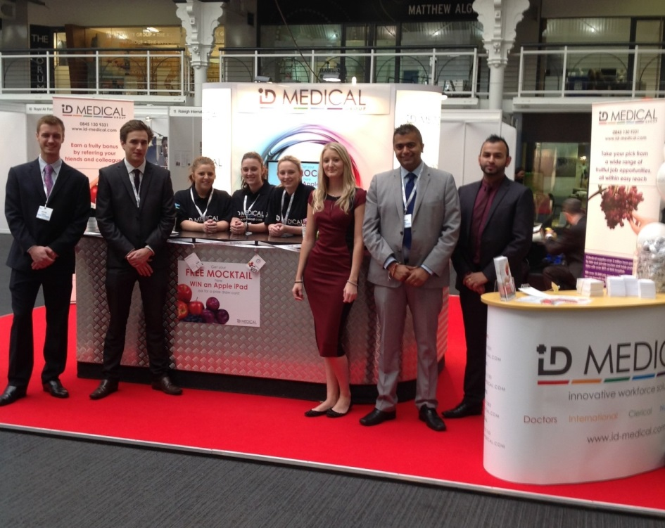

The ID Medical team at the British Medical Journal Careers Fair 2013.
Taking Best Stand Award category ensured that ID Medical welcomed the ‘cream of the crop’ by way of quality doctors to its stand at the British Medical Journal (BMJ) Careers Fair, where it unveiled its extensive selection of fruitful job opportunities to job-seeking doctors, on Friday 18th and Saturday 19th October at the Business Design Centre in Islington, London.
As a long established supplier of locum and permanent doctors to the NHS and private medical sectors, ID Medical embraces BMJ Careers as a highly effective recruitment channel to attract most professional quality and ‘best fit’ doctors. This year, ID Medical returned to integrate its bold recruitment campaign, ensuring it was ‘best of the bunch’ with its free fruity mocktail bar and iPad prize draw.
ID Medical’s 2013 Fruitful Opportunities recruitment drive targets healthcare professionals across all of its sectors; doctors, nurses, AHP/HSS, clerical, international and mental health, announcing that the UK’s leading multi-disciplinary recruiter, which holds preferred supplier contracts with over 80% of hospitals, and which supplies over 2 million hours to the NHS each year, has an abundance of job opportunities to choose from….jobs that are exceedingly rewarding – or ‘fruitful’.
ID Medical’s head of marketing, Caryn Cooper, commented “Every year we look forward to the high traffic footfall the BMJ Careers Fair brings, allowing us to meet face-to-face with truly valued medical professionals; and this year we added a fun element, theming our activities around our memorable Fruitful Opportunities marketing campaign.
“Our Fruitful concept for the stand turned heads, ensuring the best doctors were attracted to receive a free fruit mocktail and enter our daily Win an iPad prize draw, concluding their visit by registering to be included in ID Medical’s abundance of career opportunities.”
The BMJ Careers Fair is a key event within ID Medical’s calendar, providing its recruitment consultants with the opportunity to network with candidates, offer career advice and enable employment-seeking doctors to explore an array of its fruitful locum job opportunities.
ENDS
Caryn Cooper
head of marketing
ID MEDICAL - ID House - 1 Mill Square - Wolverton Mill South - Milton Keynes - MK12 5ZD
t: +44 (0) 1908 555 498 f: +44 (0)1908 552 825
w: id-medical.com e: caryn.cooper@id-medical.com
Notes to editors
About ID Medical
ID Medical (HQ in Milton Keynes with office in central London) was established in 2002 and has since maintained its enviable position as market leader in the provision of high calibre medical staffing to both the public and private medical sectors. As the UK’s leading provider of locum doctors, nurses and AHP/HSS and clerical staff, ID Medical holds preferred supplier contracts with over 80% of hospitals nationwide and supplies over 2 million hours to the NHS per annum.
Founded on its core principles of quality of service, dedication, innovation and commitment, the ID Medical Group Limited provides a complete medical staffing solution to its valued partners, forming part of the NHS procurement.

2013 has been a year filled with recognition of ID Medical’s first-rate capacity to provide a premier level service to its valued candidates and clients, with the company firmly positioned within the annual Recruiter FAST 50 league, Sunday Times 100 Best Companies to Work for 2013, Investec Hot 100, Recruitment International Top 250 and the REC IRP Awards 2013. This demonstrates ID Medical’s commitment to the industry whilst validating its credibility as market leader.

