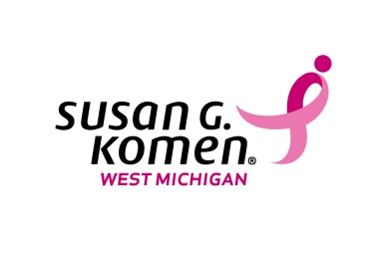
FOR IMMEDIATE RELEASE

Media Contact:
Kim Bode
834 Design & Marketing
616.299.2677
kim@834design.com

LOCAL BREAST CANCER ORGANIZATION TO HONOR BREAST CANCER ACTIVISTS AND SUPPORTERS
Susan G. Komen West Michigan announces today a new event honoring community members who have used their position and influence to combat breast cancer

Grand Rapids, Mich.– Susan G. Komen West Michigan will hold the inaugural Powerfully Pink event on Tuesday, November 5, 2013 at 5:30 p.m. at the Gerald R. Ford Presidential Museum in downtown Grand Rapids. The event will honor local men and women who use their voice, networks, resources and passion to make a difference in the fight against breast cancer. The event will specifically honor the six organizations that currently use Komen West Michigan funds to provide breast screenings, mammograms, diagnostics and genetic testing for local men and women who cannot afford those services.
“Komen West Michigan was founded on the passion and strength of our survivors and co-survivors,” said Jennifer Jurgens, Komen West Michigan executive director and breast cancer survivor. “Women like Betty Ford and others have set an example of how a person can use their position and passion to further a cause. Powerfully Pink women and men will be recognized at this event for all they have done for this community by using their skills, network, passion and position, challenging others to do the same. Everyone has the power to do something in this fight against breast cancer.”
Powerfully Pink will feature speaker Paul Templer, internationally recognized as “The Hippo Guy”, and live music by local jazz legend Edye Evans Hyde.

Paul Templer made international headlines after being swallowed by a hippo trying to save the life of another person. Templer went on to co-author the book Success Simplified, and just released a new book titled What’s Left of Me. Templer will speak about the power of choice and using one’s own circumstances to make a difference.

“Betty Ford and Paul Templer used their positions, personal networks and power to make a difference. That is Powerfully Pink,” said Jurgens. “We are asking members of the west Michigan community to join us in honoring these individuals in our community who embody Powerfully Pink; individuals that have used their passion and personal networks to combat breast cancer in west Michigan.

To reserve your spot for $50 or to learn more about Powerfully Pink, visit: powerfullypink.org.
To learn more about Susan G. Komen West Michigan, visit: komenwestmichigan.org
To read up on Paul Templer, visit: http://www.paultempler.com
###

About Susan G. Komen West Michigan
The West Michigan Affiliate of Susan G. Komen for the Cure® is dedicated to combating breast cancer at every front. Susan G. Komen West Michigan’s net income goes toward funding grants to local hospitals and community organizations that provide breast health education and breast cancer screening and treatment programs for medically underserved men and women. Komen West Michigan service area covers Kent, Montcalm, Muskegon, Newaygo and Ottawa counties. For more information, call 616.752.8262 or visit www.komenwestmichigan.org

