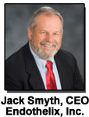 |   Ischemic Conditioning, Endothelial Function  and Enhanced External Counterpulsation:  From Research Studies to Patient Care | 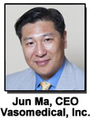

Dear Colleague:

On behalf of Endothelix, Inc., Vasomedical, Inc., and Ischemic Conditioning Therapeutics, Inc., we would like to invite you to participate in an invitation-only Scientific Focus Group Meeting held in connection with the 2013 American Heart Association Scientific Sessions in Dallas next month. The meeting will discuss state of the art science and technology related to Endothelial Dysfunction, Enhanced External Counterpulsation (EECP), Ischemic Conditioning, and their potential interactions.
The meeting will take place on Sunday, November 17 from 7:00 pm to 9:00 pm at the Aloft Hotel Downtown Dallas. Dinner will be served.
We have an unprecedented lineup of presenters including:

Dr. Todd Anderson  Dr. Gregory Barsness  Dr. Robert Kloner  Dr. Morteza Naghavi  Dr. Karin Przyklenk | Dr. Arshed Quyyumi  Dr. Ozlem Soran  Dr. Hirofumi Tanaka  Dr. Christopher Wilcox

If you accept the invitation, please simply reply with "RSVP" or see below to register and we will confirm accordingly.
We look forward to your participation in this scientific event.
Sincere regards,
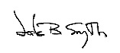  Jack Smyth  Chief Executive Officer  Endothelix, Inc. | 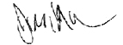  Jun Ma  Chief Executive Officer  Vasomedical, Inc.

Location: Aloft Hotel Downtown Dallas, 1033 Young St., Dallas, Texas 75202 · Phone: (214) 761-0000
Room: The “Party Pad”
Event Date: Sunday, November 17, 2013
Event Time: 7:00-9:00 pm, with dinner

Chairmen:

Robert A. Kloner, M.D., Ph.D.
Professor of Medicine, Cardiovascular Division, Keck School of Medicine, University of Southern California, Los Angeles, California
Director of Research, Heart Institute of Good Samaritan Hospital, Los Angeles, California

Morteza Naghavi, M.D.
Founder and President, Society for Heart Attack Prevention and Eradication (SHAPE)
Chief Executive Officer, Fairway Medical Technologies, Houston, TX
Sponsors:
Ischemic Conditioning Therapeutics, Inc. (Houston, Texas, U.S.A.)
Endothelix, Inc. (Houston, Texas, U.S.A.)
Vasomedical, Inc. (Westbury, New York, U.S.A.)

AGENDA

 | Welcome and Opening Remarks
10 min | Introduction to the concepts of ischemic conditioning  Robert A. Kloner, M.D., Ph.D.  Professor of Medicine, Cardiovascular Division, Keck School of Medicine, University of Southern California, Los Angeles, CA. Director of Research, Heart Institute of Good Samaritan Hospital, Los Angeles, CA | 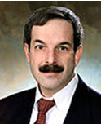
15 min | Remote ischemic conditioning: an update on mechanisms  Karin Przyklenk, Ph.D.  Professor and Director of the Cardiovascular Research Institute, Wayne State University School of Medicine, Detroit, MI | 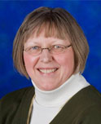
10 min | Circulating progenitor cells: marker of regenerative capacity  Arshed Quyyumi, M.D.  Professor of Cardiology, Co-Director of Emory Clinical Cardiovascular Research Institute, Department of Medicine, Emory University School of Medicine, Atlanta, GA | 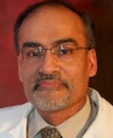
15 min | Endothelial dysfunction in specific clinical populations  Christopher Wilcox, M.D., Ph.D.  Chief of Nephrology and Hypertension, Director of Cardiovascular-Kidney Institute, Vice-Chair for Academic Affairs, Department of Medicine, George E. Schreiner Chair of Nephrology, Georgetown University Medical Center, Washington, DC | 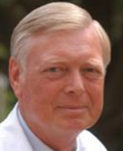
15 min | Effects of EECP therapy on CAD and heart failure treatment and integration of endothelial function measurement to follow clinical outcomes  Ozlem Soran, M.D.  Associate Professor of Medicine, Associate Professor of Epidemiology/Research, Director of EECP Treatment Lab, Heart and Vascular Institute, University of Pittsburgh, Pittsburgh, PA | 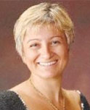
15 min | Effects of enhanced external counterpulsation (EECP) on endothelial function  Gregory Barsness, M.D.  Assistant Professor of Medicine, Division of Cardiovascular Diseases, Mayo Clinic, Rochester, MN | 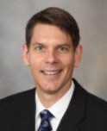
15 min | Clinical studies linking endothelial function and ischemic conditioning  Todd Anderson, M.D.  Director of Libin Cardiovascular Institute, Department Head Cardiac Science, Professor of Medicine, Department of Cardiovascular Sciences, University of Calgary, Calgary, AB, Canada | 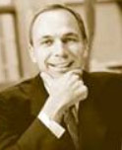
15 min | Ischemic conditioning and athletic performance  Hirofumi Tanaka, Ph.D.  Professor of Exercise Science, Director of Cardiovascular Aging Research Laboratory, University of Texas at Austin, Austin, TX | 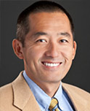
 | Q&A and Panel Discussion
 | Closing  Morteza Naghavi, M.D.  Founder and President, Society for Heart Attack Prevention and Eradication (SHAPE). Chief Executive Officer, Fairway Medical Technologies, Houston, TX | 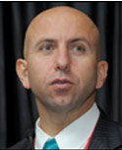
Please reply with "RSVP" to accept the invitation or reserve your seat on either the Endothelix or ICT websites.


