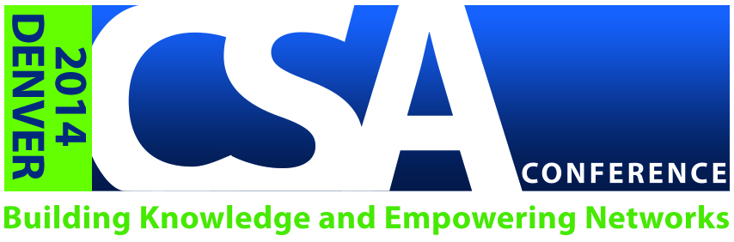
CSA Conference 2014

Session Proposal

Please return this form by November 30th in order to receive consideration for presenting at the CSA Conference. The Program Committee will begin reviewing proposals on November 1st. The 2014 conference theme is Building Knowledge and Empowering Networks to Benefit Seniors. The Program Committee asks that proposed sessions relate to the theme and adhere to program track descriptions, and that you complete all fields in this form in their entirety – incomplete forms will not be considered. Return completed forms to information@csa.us and use subject line 2014 Session Proposal.

Session and Submitter Information
Identify the Main Topic of Your Session :
Pick the Appropriate Track (Finance/Health/Public Policy/Current R&L:
Proposed Session Title:
Format Duration:  (60 Minutes Breakout or 75 Minute General Session) |  |  |  | Proposed Seating Arrangement:  (Theater/Classroom/Rounds)
Session Submitter Name: |  |  |  | Session Submitter Email:
Session Submitter Phone: |  |  |  | Session Submitter Company:

Session Abstract, Objectives and Audience
Session Abstract:
Short: 50–100 words

Learning Objective 1:
Learning Objective 2:
Learning Objective 3:
Intended Audience:
(Advanced/Intermediate/Introductory)
Advanced: Solid understanding of the more complex concepts covered in this workshop. Understanding of basic concepts is assumed and will not be covered in the workshop. Intended for someone with in depth experience in this content area. |  | Intermediate: Solid understanding of the basic concepts covered in this workshop is assumed and may not be discussed or only discussed briefly in this workshop. Intended for someone with some experience in this content area. |  |  |  | Introductory: Little knowledge of the basic concepts covered in this workshop. Intended for someone new to the area with little to no background experience in the content area.

Session Elements
Will Your Session Have the Following Elements? |  |  | Yes/No |  | Will Your Session Have the Following Elements? |  |  | Yes/No
Question and Answer Section |  |  |  |  | Facilitated Discussion
National Relevance |  |  |  |  | Audience Participation
Diverse View Points and Multiple Perspectives |  |  |  |  | Handouts and Resources

Session Usability
Will you be willing to adapt your presentation for any of the following CSA publications or educational content
Yes/No Yes/No
CSA Journal Article |  |  | CSA Webinar
Senior Spirit Article |  |  | CSA Blog Posting
Educational Guide |  |  | Public Service Presentation

Full Session Description

Speaker Information Questionnaire
Are you willing to be a part of a collaborative session if other proposals are received dealing with the same topic?
Have you presented this session before? If yes, please give specifics.
Please list any times you are not available to present on Aug 8th and 9th.
How many times have you presented at a professional conference?
Please list any specific speaking experience:
What topics have you presented on in the past?

Additional Speaker Information (if applicable)
Name of Additional Speaker | Email |  |  | Phone Number

