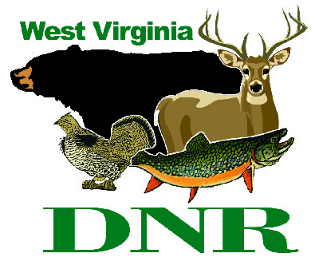 | West Virginia Division of Natural Resources www.wvdnr.gov  Earl Ray Tomblin, Governor Frank Jezioro, Director  News Release: Oct. 31, 2013  Facebook: WV Commerce - State Parks  Hoy Murphy, Public Information Officer 304-957-9365 hoy.r.murphy@wv.gov  Contact: Mike Smith, Superintendent, 304-653-4254 DNRDroopMountain@wv.gov

150th Anniversary Memorial and Monument Dedication

of the Battle of Droop Mountain Set for Nov. 6, 2 p.m.

HILLSBORO, W.Va. – The Battle of Droop Mountain was fought Nov. 6, 1863, and was a major turning point of the Civil War. On Nov. 6, 2013, 150 years to the day, a memorial service and native stone monument will be unveiled at Droop Mountain Battlefield State Park near Hillsboro in Pocahontas County. This summer, Supt. Mike Smith has organized and conducted three of four memorial hikes following the footsteps of soldiers. His fourth memorial hike is a 27-mile overnight hike from Lewisburg to Droop Mountain, arriving to the battle area on what would be the day of the battle of 1863.
Wednesday, Nov. 6, at 2 p.m., a bronze plaque secured to native sandstone rock will be part of a memorial tribute to men who died at the battle or died as a result of wounds inflicted. Terry Lowry, author of Last Sleep, will speak about why we should remember this battle; a poem by West Virginia’s past poet laureate Louise McNeill Pease will be read; re-enactors and historians will read the names of both Federal and Confederate fatalities listed on the bronze plaque and will serve as honor guards. A final bugle call will lay rest.
“The public is invited to attend what will no doubt be one of the most reverent and sincere events of West Virginia’s sesquicentennial year,” said Supt. Smith. “Vegetable soup will be kept warm in a kettle over an open fire and served with cornbread as visitors mingle and share fellowship following the ceremony.”
Anyone planning to attend should plan to arrive at least a half hour prior to the ceremony and should dress appropriately for the weather for this outdoor event.
State parks will have the program posted on the Droop Mountain Battlefield website on the History tab at www.droopmountainbattlefield.com.

The Battle of Droop Mountain
On Nov. 6, 1863, the Federal army of Brigadier General William W. Averell, in his second attempt to disrupt the Virginia-Tennessee Railroad at Salem, Virginia, faced again the Confederate troops of Brigadier General John Echols. Throughout the morning, Echols' smaller confederate army held the high ground and blocked the highway with artillery, but in the afternoon was overwhelmed by the crushing advance of Federal infantry on his left flank. Following the collapse of his lines, General Echols retreated south into Virginia with the remnants of his command.
Federal Troops occupied Lewisburg Nov. 7, 1863, but being burdened with prisoners and captured livestock, General Averell elected to return to his headquarters in Beverly, W.Va., waiting until early December to lead a third and ultimately successful attack on the vital railroad. Operations in the Shenandoah Valley in the spring of 1864 drew remaining confederate troops out of West Virginia, thus leaving the new state securely under the control of the federal government for the remainder of the war.

**DNR**

Photo Courtesy of the West Virginia Department of Commerce.
Droop Mountain Battlefield State Park Supt. Mike Smith will lead a 150th anniversary memorial service of the Civil War battle Nov. 6 at 2 p.m. at the park.

