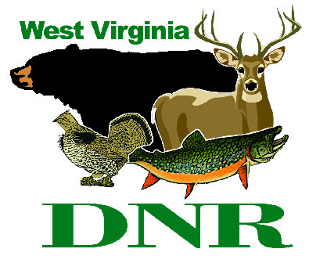 | West Virginia Division of Natural Resources www.wvdnr.gov  Earl Ray Tomblin, Governor Frank Jezioro, Director  News Release: Oct. 31, 2013  Facebook: WV Commerce - State Parks  Hoy Murphy, Public Information Officer 304-957-9365 hoy.r.murphy@wv.gov  Contact: Paul Redford, District Administrator, WV State Parks  304-558-2764 DNR.Parks@wv.gov

Online reservation service for Pipestem Resort State Park

campsites starts Nov. 1, 2013

PIPESTEM, W.Va. - Pipestem Resort State Park’s new camping reservation policy begins Nov. 1, 2013. Reservations for campsites at Pipestem will be accepted online, by telephone, and by mail one year in advance from the first day of each month, according to Paul Redford, district administrator for West Virginia State Parks.
“It’s more camper-friendly,” Redford said. “Today’s RVer and tent camper wants the security of a reserved site, particularly at Pipestem. The park’s popularity keeps the campground busy; however, some campers may not take a chance of finding a site without a reservation.”
Redford calls the online reservation system, combined with the ability to make reservations a year in advance, online or by phone, “a good change.”
Prior to the Nov. 1 reservation policy change, campers could begin making reservations in mid-February via a mail-in process, followed by a phone-in and call-in process. Postcards have been mailed to previous park visitors who use the campground facilities that changes are occurring. The notice is also posted on www.wvstateparks.com, under “Special Notices.”
To reserve online, follow the prompts on the “Online Reservation” tab at www.pipestemresort.com. Lodge rooms and cabin rentals also can be made using the online service. For more information call 304-466-1800.

**DNR**

Photos Courtesy of the West Virginia Department of Commerce.
Campers enjoy staying at Pipestem Resort State Park.
Beginning Nov. 1, 2013, campsite reservations may be made up to one year in advance at Pipestem Resort State Park.

