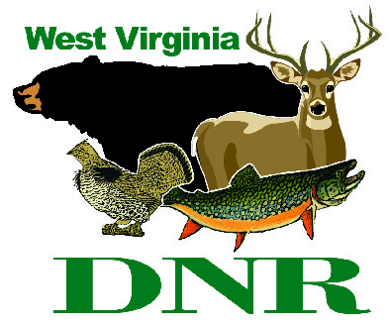 | West Virginia Division of Natural Resources www.wvdnr.gov  Earl Ray Tomblin, Governor Frank Jezioro, Director  News Release: Oct. 31, 2013  Facebook: WV Commerce - State Parks  Hoy Murphy, Public Information Officer 304-957-9365 hoy.r.murphy@wv.gov  Contact: Paul Redford, District Administrator, dnr.parks@wv.gov, 304-558-2764

Special Lodging Rates at West Virginia State Parks

Recognize Veterans Nov. 1-15, 2013

Veterans Day Golf Discount at State Parks Nov. 11

SOUTH CHARLESTON, W.Va. – Veterans staying at a West Virginia state park the first two weeks of November are eligible for special overnight rates.
“The Veterans Day appreciation program has been offered for many years,” said Paul Redford, district administrator for West Virginia State Parks. “It is quite popular and appropriate as many West Virginians have served in the military and we offer this rate to thank them for their service.”
Room and cabin rates are reduced Nov. 1-15, 2013. The rate special is available to all military personnel who have served or who currently serve in the reserves or are on active duty. Presentation of military or veteran status is requested.
The program is available any rental night with the exception of two-night rentals on weekends for cabins or cottages, and is based on availability. Reservations are requested and, when calling for reservations, ask for the Veterans Appreciation rate.
Participating areas are: Beech Fork, Blackwater Falls, Bluestone, Cacapon Resort,, Canaan Valley Resort, Cass Scenic Railroad, Chief Logan Lodge, Hawks Nest State Park, Holly River, Lost River, North Bend, Pipestem Resort, Stonewall Resort, Twin Falls Resort, Tygart Lake and Watoga state parks, and Kumbrabow and Seneca state forests.
Veteran’s Appreciation and other overnight packages information are posted on the park website. To learn more about West Virginia State Parks, visit www.wvstateparks.com.
***
Veteran’s Day Golf Discount at West Virginia’s State Parks Nov. 11
If weather conditions are right on Veteran’s Day, Monday, Nov.11, 2013, West Virginia state parks golf professionals encourage golfers to hit the fairways.
“November days can be autumn-like. The Veterans Day rate offer encourages late season golf play,” said Paul Redford, district administrator for West Virginia State Parks.
Golf play Nov. 11 is $23 per person for 18-hole play and a shared cart at Twin Falls or Pipestem resort state parks. The fee includes state sales tax and offered to any golfer and tee time.
For golf information, call Twin Falls, 304-294-4000 or Pipestem, 304-466-1800. To learn more about West Virginia’s state parks, visit www.wvstateparks.com.

**DNR**

Photo Courtesy of the West Virginia Department of Commerce.
Twin Falls State Park is one of the West Virginia state parks and forests offering a Veterans Day Appreciation lodging discount Nov. 1-15, 2013.

