

FOR IMMEDIATE RELEASE

Nov. 5, 2013

**Innovative Octagonal Cast Iron Skillet on Track for Holiday Shipping, Confirms Finex**™

**Portland, OR –** [Finex’s](http://www.finexusa.com) launch of their 12” cast iron skillet on [Kickstarter](http://www.kickstarter.com/projects/1830780035/731137767?token=f5ab11e6) received an enthusiastic welcome, securing over **333% funding** with over one week still remaining in the campaign period. This is Finex's debut product, a long-overdue redesign of a true American classic.This skillet sports an octagonal shape, a quick-cooling wire-spring handle, and a polished computer numerical control (CNC)-machined interior. It’s the first cast iron cookware fully designed and manufactured in the Pacific Northwest, paying homage the centuries-old foundation of great stove work, the premium cast iron skillet.  
  
“Incredible... *truly incredible,”* said Mike Whitehead, founder of Finex. “It’s both humbling and energizing to see this outpouring of support. I’m delighted so many folks out there share my passion for innovative high quality cookware that still stays true to its traditional roots.”

This Finex skillet retains cast iron’s time-honored cooking superiority and durability without the toxicity concerns that comes with much of modern cookware. The skillet’s octagonal shape lets cooks stand the skillet on its side (handy for drying and convenient for storage) Because each of its six corners become a pour-spouts, pouring becomes almost magically simple at any angle. The spring handle harkens back to the classic woodstove handles that prevented cooks from burning their hands when stoking wood-fired cook stoves. The spring handle‘s ample air space cools quickly after use.

With the practicality of a cast iron skillet coupled with a stunning new design, this fully US-designed and manufactured cookware is the perfect gift for discriminating cooks. Just in time for the holidays,   
on Nov. 2, Finex completed the patterns and confirmed everything is on track for first shipments by the December 15, 2013 target.

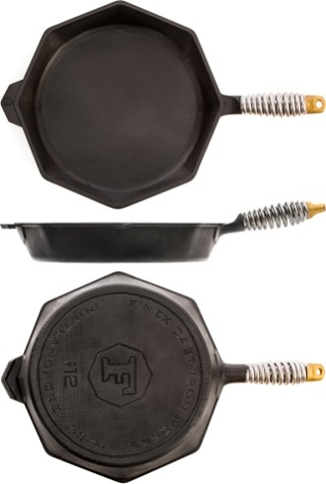  
Finex is continuing to raise funds for their 12” cast iron skillet through [Kickstarter](http://www.kickstarter.com/projects/1830780035/731137767?token=f5ab11e6) campaign through November 17, offering supporting funders special pre-release pricing of $125 for estimated February 2014 delivery and $165 for estimated December 2013 delivery. These shipment dates are before the official start of sales in Q1, 2014 for $195 MSRP through select channels.

Contact

For more information, visit [www.FinexUSA.com](http://www.FinexUSA.com/); or e-mail cookwithus@FinexUSA.com

High-resolution images available at <http://www.FinexUSA.com/press-resources/>  
