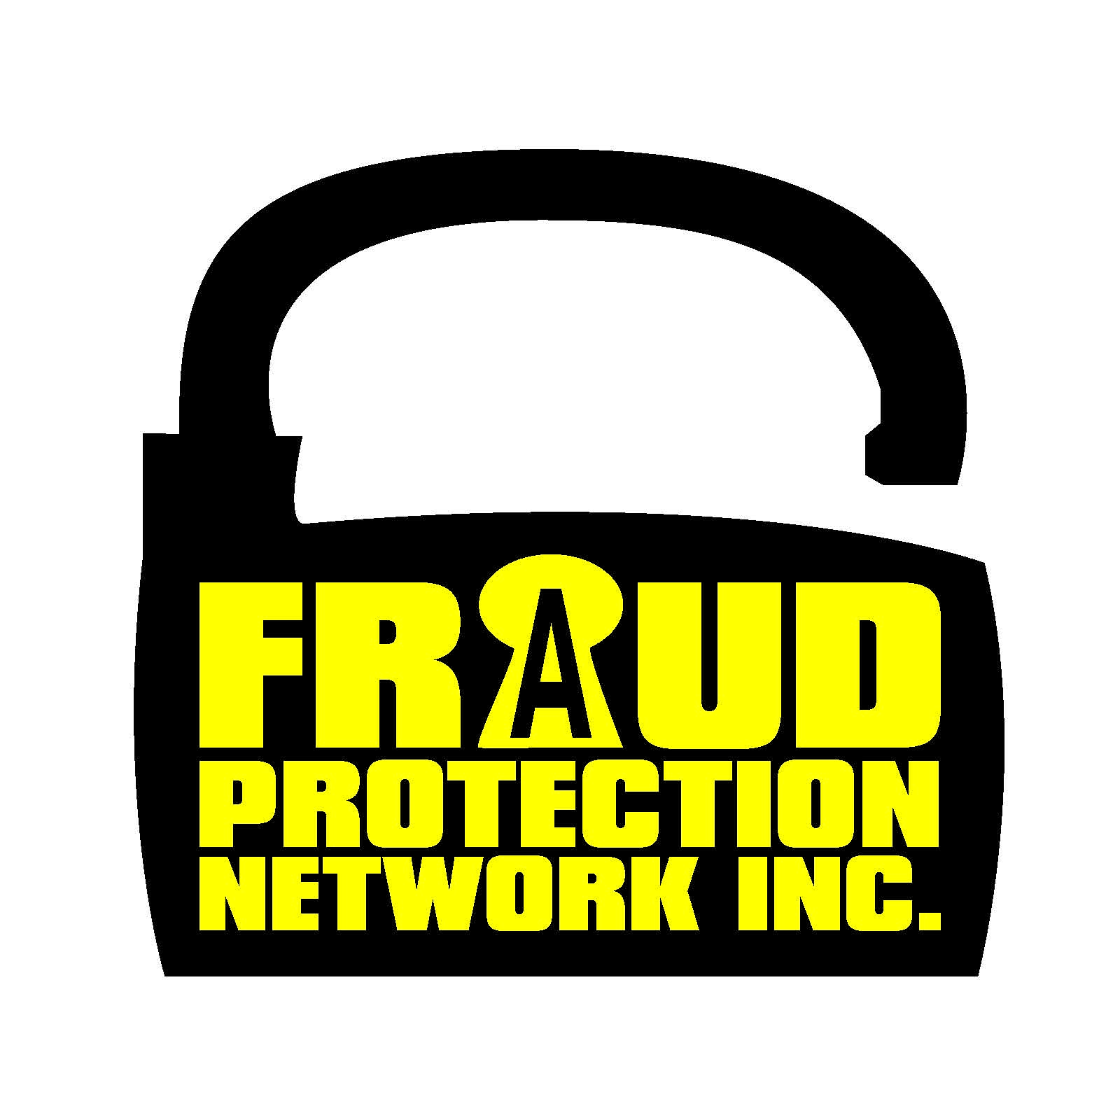
Fraud Protection Network, Inc.
2500 E. Hallandale Beach Blvd, Suite 404,
Hallandale Beach, FL 33009
Toll Free: (855) 203-0683 Fax: (855) 280-0672
Website: http://fraudprotectionnetworkinc.com
Email: admin@fraudprotectionnetworkinc.com

The Fraud Protection Network a Licensed, Bonded and Insured Entity in the State of Florida. Unlike identity theft companies, at Fraud Protection Network Inc., our only focus is on consumer and investment fraud. Your member benefits include comprehensive reports and extensive background checks on any registered or unregistered company, individuals, or investment opportunities you are considering.

As for the STATISTICAL REVIEW AS OF 2012 YOU ARE MORE LIKELY TO GET SCAMMED MORE NOW THAN EVER BEFORE with over 30 million cases documented this year alone. It is just a matter of time, until you may become a victim of fraud. Odds are that 1 in 3 Americans will be scammed over the course of next year. If you shop online, invest, or plan on trying to sell something, you are probably next in line.

Here are some facts that you should know:
- More than 30 million consumers are defrauded each year.
- The Federal Fraud Enforcement Task Force uncovered more than $8billion in securities, commodities and investment fraud losses alone in 2012.
- Communication methods for fraud are fairly evenly distributed over print (27%), internet (22%), and television/radio (21%), with an additional 8.4% by telemarketers.
- “Only 1/2 of known investment fraud victims admit to ever losing money due to being misled or defrauded.”
- Investment fraud victims are almost twice as likely to hold a college degree as a non-victim.
- Investment fraud victims are 20% more likely to be married than non-victims.
- 9 out of 10 investment fraud victims are men.
- 3/4 of business opportunity fraud victims are men.
- 4 in 10 lottery fraud victims are men.
- Half of all workplace fraudsters are senior managers.
- 8 in 10 investment fraud victims who admitted being defrauded were introduced to the fraudster through a friend or family member.

Allow FRAUD PROTECTION NETWORK INC.TO STOP THE FRAUD BEFORE IT HAPPENS to you!
We are a nationally recognized leader in full service fraud protection. By becoming a member today, you have taken the first step toward protecting your hard earned money from scammers and fraudsters. Put our team of research and due diligence specialists to work for you right away!

