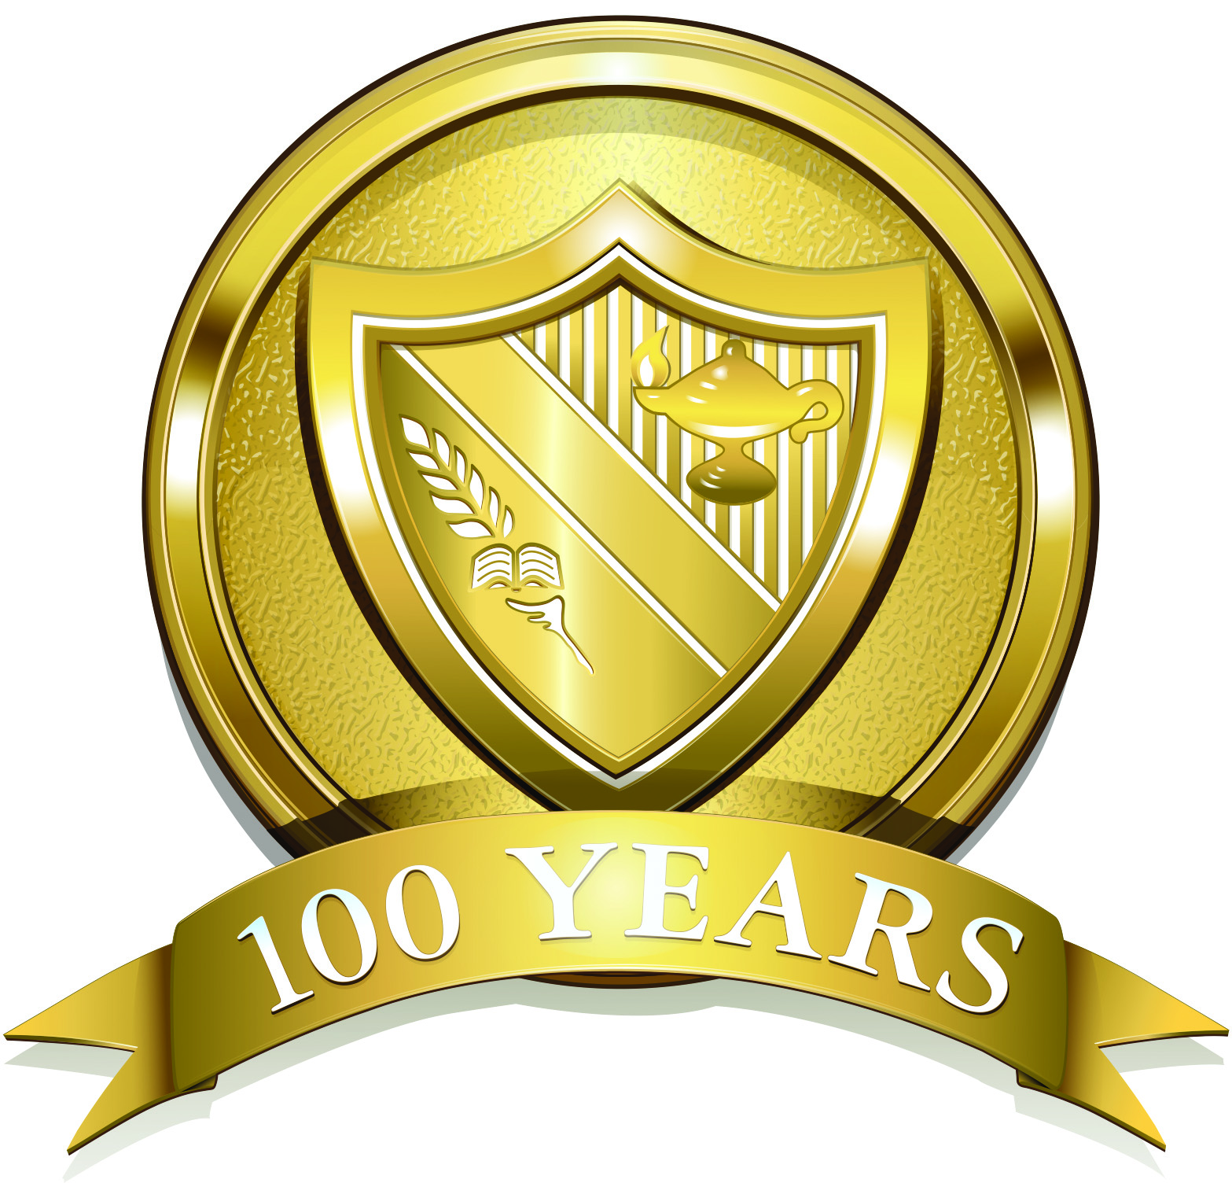

The Hun School of Princeton
176 Edgerstoune Road, Princeton, New Jersey 08540, www.hunschool.org

Media Release November 7, 2013
Contact: Maureen Leming
Director of Communications and Marketing
(609) 921-7600, extension 2299
maureenleming@hunschool.org

Lisa Yacomelli and Allan Arp Awarded Excellence in Teaching Honors

Princeton, NJ – The Hun School of Princeton recognized Lisa Yacomelli and Allan Arp, two exemplary members of the faculty, on Tuesday, November 5th with Excellence in Teaching Awards. Ms. Yacomelli received the James M. Byer ’62 Excellence in Teaching Award and Mr. Arp received the Junior Teaching Award.

Students of Ms. Yacomelli and Mr. Arp introduced their teacher, and explained how their instructor has personally inspired them.

Kamaron McNair ’14 said of Ms. Yacomelli, “Not only will Ms. Yacomelli set expectations high enough for us to overachieve, she will stop at nothing to make us reach them.”

“In the three years I have had Mr. Arp as a teacher, whether in Art class, or in Art and Design, I have never done a project or activity that wasn’t fun, or that I didn’t like. Mr. Arp interacts with his students well, and always guides them in the right direction for success,” said Myles Hutcherson ’18.

The Excellence in Teaching Awards are endowed faculty prizes awarded to advance teaching and learning at The Hun School. The biennial awards are presented to teachers who, by nomination of their colleagues, have distinguished themselves through their work as educators. The aim of the James M. Byer ’62 Excellence in Teaching Award is to distinguish outstanding classroom teaching, the creation of challenging and innovative courses, creation or use of new and innovative teaching methods and course materials, and supervision of creative projects. The Junior Teaching Award is meant to celebrate junior faculty who exhibit qualities associated with effective teaching, and encourages development of these qualities.

Past recipients of these awards include:

James M. Byer ’62 Excellence in Teaching Award
Julie Davis
Dana Radanovic
Dianne Somers

Junior Teaching Award
Lynn McNulty
Julie Shuler-Misra
Ryan Brown

Photograph caption:
IMG_0077.jpg – Headmaster Jonathan Brougham congratulated the James M. Byer ’62 Excellence in Teaching Award recipient Lisa Yacomelli and the Junior Teaching Award recipient Allan Arp for their exemplary classroom work.

About The Hun School of Princeton:
The Hun School of Princeton is a co-educational, boarding school and day school founded in Princeton, New Jersey. The Hun School is a private college preparatory school in which student-centered learning prepares students for the global community in which they will live and work. Individual attention and strong student-faculty relationships are the hallmarks of the School. The Hun School is comprised of 629 students in its Middle School, Upper School, and Postgraduate Program. With a strong commitment to diversity, The Hun School welcomes students from seventeen countries and fifteen states.

