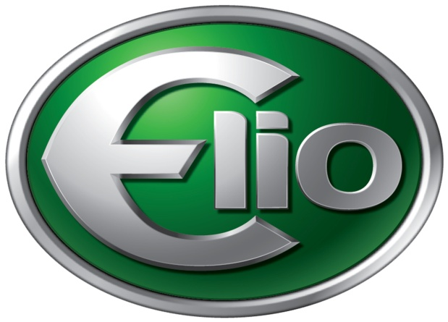

For Immediate Release Contact: Allison Hurt
BERLINE
248-535-2838 (c)
248-593-7434 (o)

Elio Motors Experiences More Legislative Success with Approval of Senate Bill 390 in Michigan

November 8, 2013 – Startup transportation company Elio Motors continued their streak of legislative success with the unanimous passing of Senate Bill 390 in Michigan yesterday. This bill, sponsored by Senator John Moolenaar, removes the technical requirement for motorcycle endorsements for autocycles – completely enclosed three-wheel motorcycles with automotive controls.

Joel Sheltrown, Vice President of Governmental Affairs for Elio Motors said the unanimous vote in both Chambers signals the understanding by the legislature of the need for this common sense change. “In all states where we have asked for legislation to be considered, it has passed unanimously. There has been no opposition in committee testimony either. In the times we live in, that kind of bipartisan support is encouraging,” he said.

The clearance of Senate Bill 390 is especially exciting for Elio Motors as they intend to introduce their three-wheel, $6,800, 84 mpg vehicle to the U.S. car market in the fourth quarter of 2014. Once the bill is signed by Governor Snyder, Michigan will follow in the footsteps of California, Texas and other states which allow the Elio to be driven without a motorcycle endorsement.

“There is still some work to do, but the Elio Motors Governmental team is aggressively pursuing helmet and licensing law changes where needed with much success,” added in Paul Elio, Chief Executive Officer for Elio Motors.

(more)

About Elio
Elio Motors was born out of Paul Elio’s vision for an efficient and affordable revolutionary vehicle. The American made, three-wheel vehicle boasts 84 mpg on the highway and 49 mpg in the city, plus an anticipated 5-star safety rating. At $6,800, this vehicle is for everyone. For more information, please visit http://www.eliomotors.com or www.facebook.com/ElioMotors.

###

