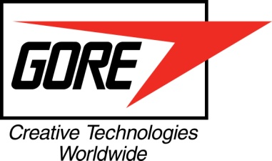
for immedIATE RELEASE

Contact: Gail Smith Berry
W. L. Gore & Associates
+44 (0) 1382 569245
gsmithbe@wlgore.com

NEW GORE® SHIELDED TWISTED PAIR CABLES DELIVER HIGH-SPEED
DATA TRANSMISSION IN A HIGH-DENSITY LIGHTWEIGHT PACKAGE

LANDENBERG, PA, NOVEMBER 15, 2013 – W. L. Gore & Associates has introduced a new line of GORE® Shielded Twisted Pair Cables, now constructed with uniquely engineered fluoropolymers to significantly reduce weight while maintaining reliable signal integrity for the most demanding environments of civil and military aerospace applications.

Gore will be exhibiting these new cables at the Dubai Airshow, Dubai World Central, November 17-21, 2013, Stand 2415.

These cables maintain high-speed communication between avionics transmitters and receivers and meet the performance requirements of ANSI/NEMA WC27500 Standards for Aerospace and Industrial Electrical Cable, type 24. They deliver high-speed transmission in a particularly lightweight package due to materials that reduce jacket weight by as much as 37 percent when compared to ethylene tetrafluoroethylene (ETFE) materials and 50 percent when compared to fluorinated ethylene propylene (FEP).

These lighter-weight materials result in smaller cable diameters with a tight bend radius, which ultimately translates to substantially smaller, lighter, and higher-density cable bundles for easy routing in confined spaces, making them especially well-suited for mil/aero harness applications.

GORE® Shielded Twisted Pair Cables provide high-speed data transmission over long distances, minimizing the need for additional signal amplification. Constructed from materials engineered to withstand flight demands, they provide reliable performance in extreme environments.

For more information, visit this page.

http://www.gore.com/en_xx/products/cables/highdatarate/aircraft/shielded-twisted-pair-wire-2.html

About W. L. Gore & Associates, Inc.
Gore is a technology-driven company focused on discovery and product innovation. Well known for waterproof, breathable GORE-TEX® fabric, the company’s portfolio includes everything from high- performance fabrics and implantable medical devices to industrial manufacturing components and aerospace electronics. Founded in 1958 and headquartered in Newark, Del., Gore posts annual sales of more than $3.2 billion and employs approximately 10,000 associates with manufacturing facilities in the United States, Germany, the United Kingdom, Japan and China, and sales offices around the world. Gore is one of a select few companies to appear on all of the U.S. “100 Best Companies to Work For” lists since the rankings debuted in 1984. The company also appears regularly on similar lists around the world. Learn more at gore.com.

# # #

