Altium Wins EDN China Innovation Award for Sixth Consecutive Year
Altium Designer 2013 was honored with Excellent Product in
Development Tool and Software category

Shanghai, China – November 28, 2013 –Altium Limited, a global leader in Smart System Design Automation and provider of advanced 3D PCB design solutions (Altium Designer) and embedded software development (TASKING), has announced that Altium Designer 2013 has been honored with the Excellent Product in Development Tool and Software category of EDN China Innovation Award 2013. This year’s award marks the sixth consecutive year that Altium has won in this category.

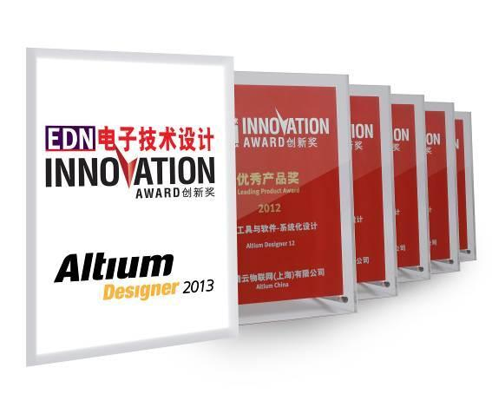
Caption: Altium Designer 2013 wins Excellent Product of EDN China Innovation Award, which marks the sixth time in a row for Altium to win this award

The EDN Innovation Award, which originated in Silicon Valley, is widely recognized as the most prestigious award in the micro-electronics field. Since 2005, EDN China has organized the Chinese version of the award annually to encourage innovation in product design, and help boost the rapid and long-term growth of China’s electronics industry. This year, EDN China invited 500,000 engineers and online users to participate in online voting for the 2013 Innovation Awards. The selection process was comprised of three phases: nomination, online voting and expert identification to ensure professionalism, authority and fairness.

“Since the EDN China Innovation Award was established nine years ago, we’ve witnessed the growth of many innovative companies who’ve helped drive the rapid expansion of the Chinese electronics industry,” said Grace Wu, Associate Publisher of EDN China. “As a pioneer in the electronics industry, Altium is deserving of this award due to its ongoing commitment to inspiring innovation in PCB design with its powerful and easy-to-use Altium Designer.”

“It is a great honor for us to receive the EDN China Innovation award for the sixth consecutive year, and is further proof of Altium's ongoing spirit of innovation,” said Max Cang, Marketing Manager of Altium China. “The Altium team works tirelessly to perfect Altium Designer to ensure our customers have the best product to push the boundaries of traditional design. With Altium Designer, our end-users are better able to overcome design and data management challenges, while they leverage the latest technologies available in building next generation electronic products.”
Altium Designer 2013 is a significant milestone in the company’s history as it not only delivers new and enhanced features, but also opens up Altium’s design platform to key partners. This creates a range of opportunities for users, partners and system integrators and represents a quantum leap for the industry. Altium Designer 2013 further improves the design environment for users by delivering several new PCB features and updates to the core PCB and Schematic tools.

The recently released Altium Designer 14 further extends the advantages of Altium Designer 2013 by providing industry first support for flex and rigid-flex design. This enables engineers and design teams to reduce workload as well as improve efficiency, which allows customers to lower the design cost and provide innovative differentiated electronic products for the market.

ENDS
Contacts:

Americas | Wendy Krugman  The Hoffman Agency  +1 408 859 6394  wkrugman@hoffman.com | Lawrence Romine  Altium United States  +1 760 231 0752  lawrence.romine@altium.com
EMEA | Gabriele Amelunxen  PRismaPR  +49 8106 247 233  info@prismapr.com | Frank Krämer  Altium Europe GmbH  +49 721 8244 108  frank.kraemer@altium.com
Monika Cunnington
PRismaPR (UK, Scandinavia, Benelux)
+44-20 8133 6148
monika@prismapr.com
APAC | Celine Han  Altium Public Relations  +86 186 1685 9685  celine.han@altium.com
Greater China | 王婷  霍夫曼公关顾问（北京）有限公司  电话: + 86 (0) 21 62033366-136  电子邮件：dwang@hoffman.com | 仓巍  Altium中国  电话：+86 21 6182 3922  电子邮件：max.cang@altium.com

ABOUT ALTIUM

Altium Limited (ASX:ALU) is an Australian multinational software corporation that focuses on 3D PCB design, electronics design and embedded system development software.

Altium Designer, a unified electronics design environment links all aspects of smart systems design in a single application that is priced as affordable as possible. Altium's embedded software compilers are used around the globe by carmakers and the world's largest automotive Tier-1 suppliers. With this unique range of technologies Altium enables electronics designers to innovate, harness the latest devices and technologies, manage their projects across broad design ‘ecosystems’, and create connected, intelligent products.

Founded in 1985, Altium has offices worldwide, with US locations in San Diego and Boston, European locations in Karlsruhe, Amersfoort and Kiev and Asia-Pacific locations in Shanghai, Tokyo and Sydney. For more information, visit www.altium.com. You can also follow and engage with Altium via Facebook, Twitter and YouTube.

