Altium Delivers Team Configuration Management Solution and New Version of Vault Technology

Altium Launches a New 1.2 Version of Altium Vault Server in conjunction with the all New Team Configuration Center, providing the next generation of high integrity, smart team and design data management

Sydney, Australia – 3 December 2013 – Altium Limited, a global leader in Smart System Design Automation, 3D PCB design (Altium Designer) and embedded software development (TASKING), announces the release of, Altium Vault Server Version 1.2 and all new product Team Configuration Center (TC2).

Hosted on an organization's own network infrastructure, the Altium Vault manages native electronic design data, including its revision history, life-cycle state and supply chain information. This new release adds ability to migrate data from one vault to another, and enhanced support for connecting to corporate enterprise systems, such as ERP and PLM.

Altium Vault Server ensures that files released to manufacture meet release requirements and approvals. Additionally, re-used design elements offer a proven track record, so components being designed-in are viable for the lifecycle of the product. Organizations have a clear understanding of the upstream and downstream effects of the deprecation of any of these elements using powerful “where-used” capabilities.

Key Business Benefits of Altium Vault Server 1.2
- Traceability and Where-Used Information through disciplined revisioning.
- Shortened design cycles through design reuse.
- Risk reduction through smart supply chain intelligence during design time, not after where it is most costly.

A full overview of the Altium Vault Server can be found on http://www.altium.com/en/products/altium-vaults

“We often see talented design teams having to work within processes that actually stifle innovation and provide little supply chain information during the design phase,” said, Marc Depret, Product Manager at Altium. “Engineers can spend as much as half their day just managing data. With Altium Vault Server 1.2, they can focus on innovation, not endless paperwork and inefficient checklists.”

Based on Vault technology Altium’s new Team Configuration Center (TC2), helps organizations centralize and standardize their design environment. Everything from design tool setup and configuration to document templates and manufacturing file formats, can be set up and automatically deployed to each engineer’s desktop.
This is a significant development, because failing to maintain a standard set of design styles and tool set-ups has an often overlooked impact on team productivity.
Until now, some organizations have turned to alternatives such as OS imaging or endpoint management tools. However these solutions can be complicated to deploy and lack any understanding of a design team’s true requirements.
By combining the Team Configuration Center with an Altium Vault, engineering team leaders can be confident that their designers are:
- Working in a ready-to-go, reliable and company approved design environment
- Using CAD library components that are known to be good and have acceptable supply chain solutions
- Handing off designs to manufacturing that have passed checking and are in the correct format

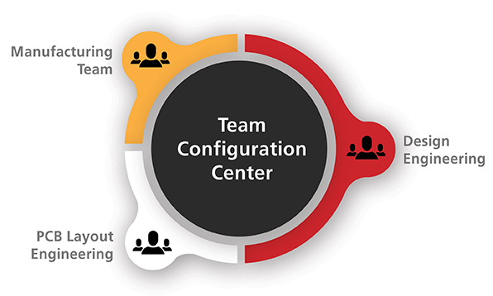
Altium TC2 avoids problems associated with managing and deploying engineering team design environments

A full overview of the Altium Team Configuration Center can be found on http://www.altium.com/en/products/altium-vaults/team-configuration-center
License options
The Altium Vault Server and TC2 are a separate licensing options, pricing is based on an individual organization’s needs. TC2 can be installed standalone or integrated with the Altium Vault Server.

Contacts:
Americas | Wendy Krugman  The Hoffman Agency  +1 408 859 6394  wkrugman@hoffman.com | Lawrence Romine  Altium United States  +1 760 231 0752  lawrence.romine@altium.com
EMEA | Gabriele Amelunxen  PRismaPR  +49 8106 247 233  info@prismapr.com | Frank Krämer  Altium Europe GmbH  +49 721 8244 108  frank.kraemer@altium.com
Monika Cunnington
PRismaPR (UK, Scandinavia, Benelux)
+44-20 8133 6148
monika@prismapr.com
APAC | Celine Han  Altium Public Relations  +86 186 1685 9685  celine.han@altium.com
Greater China | 王婷  霍夫曼公关顾问（北京）有限公司  电话: + 86 (0) 21 62033366-136  电子邮件：dwang@hoffman.com | 仓巍  Altium中国  电话：+86 21 6182 3922  电子邮件：max.cang@altium.com

ABOUT ALTIUM

Altium Limited (ASX:ALU) is an Australian multinational software corporation that focuses on 3D PCB design, electronics design and embedded system development software.

Altium Designer, a unified electronics design environment links all aspects of smart systems design in a single application that is priced as affordable as possible. Altium's embedded software compilers are used around the globe by carmakers and the world's largest automotive Tier-1 suppliers. With this unique range of technologies Altium enables electronics designers to innovate, harness the latest devices and technologies, manage their projects across broad design ‘ecosystems’, and create connected, intelligent products.

Founded in 1985, Altium has offices worldwide, with US locations in San Diego and Boston, European locations in Karlsruhe, Amersfoort and Kiev and Asia-Pacific locations in Shanghai, Tokyo and Sydney. For more information, visit www.altium.com. You can also follow and engage with Altium via Facebook, Twitter and YouTube.

