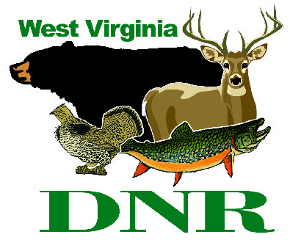 | West Virginia Division of Natural Resources www.wvdnr.gov  Earl Ray Tomblin, Governor Frank Jezioro, Director  News Release: Dec. 16, 2013  Facebook: WV Commerce - State Parks  Hoy Murphy, Public Information Officer 304-957-9365 hoy.r.murphy@wv.gov  Contact: Rob Gilligan, superintendent, Canaan Valley Resort State Park 304-866-4111 CanaanValleySP@wv.gov

Canaan Valley Resort Features Magic Carpet Rides

DAVIS, W.Va. - Skiers and tubing enthusiasts will not step inside Steppenwolf’s 1960s-era song “Magic Carpet Ride,” but they will find an outdoor conveyor that transports people up the slopes at Canaan Valley Resort State Park. This winter will be the first full season using the magic carpet equipment at both the tubing park and the downhill ski access area. In early 2013, Canaan Valley Resort opened a new 1,200 foot, eight-lane, tubing park and a new beginner’s ski area and downhill ski upgrades.
“The Magic Carpet brings another mobile experience to winter recreation,” said Dave Vance, ski area assistant manager at Canaan Resort. “Winter recreation just keeps getting better at Canaan Valley. The tubing park is awesome and the response from visitors last winter about the beginners ski area and slope access was excellent.”
The slopes at Canaan Valley opened Dec. 14, 2013. To learn more about Canaan Valley Resort, new lodge accommodations, group services and winter sports, call 304-866-4121 or visit www.canaanresort.com.

Winter sports experiences at Canaan Valley Resort and Conference Center include:
- A covered, outdoor ice skating rink overlooks the valley and the Allegheny Mountains. The rink, located behind the main lodge building, features an outdoor fireplace.
- An indoor heated pool, whirlpool spa, fitness center, and sauna is part of the new Canaan Valley Lodge, which opened in October 2013. Guests in the lodge, cabins and cottages enjoy these facilities as part of the overnight experience, and these facilities are also open to the public for a nominal fee.
- Thirty kilometers of marked, un-groomed trails and acres of wide-open meadows are open for cross-country skiing and snowshoeing adventure as weather permits. There are no trail fees for cross-country or snowshoeing.
- The new tubing park at Canaan Valley Resort is the longest tube park in the Mid-Atlantic region. Complete with rentals, warming hut, concessions and fireplace, the tubing park with the magic carpet mountaintop access will become one of the resort’s most popular outdoor winter activities for families and friends groups. The tubing park ticket prices include the tube and magic carpet ride.
- A beginner ski slope with dedicated ski school teaching area and Magic Carpet are part of the learning area, with access from parking areas and to the main downhill ski slopes.
- Downhill skiing slopes reach a summit elevation of 4,280 feet with a vertical drop of 850 feet. Forty-three trails make up the downhill ski experience. An average natural snowfall of 180 inches is typical of winter conditions in the Tucker County area. There is snowmaking on 75 percent of the trails. More than 30 percent of the terrain at Canaan Valley is dedicated to beginners and Timber Trail is a guest favorite (1.25 miles long). A dedicated trail, Critters Crawl for beginners was added to the ski area in 2013 and includes a Magic Carpet for increased ease of user access. The remaining trails cater to intermediate skiing (40 percent) and advanced/expert (30 percent). Canaan Valley features three lifts: 1 quad and 2 triples, plus two magic carpet transports.
- Rentals, concessions and ticket sales for downhill skiing are at the Bear Paw complex. Rentals include ski, ski equipment and snowboard rentals. Daily, night, two- and three-day rentals are available. Tube rentals are located at the Tubing Park area. Cross-country skis and snowshoe rentals are available at the XC Ski Center near the state park office.

**DNR**

