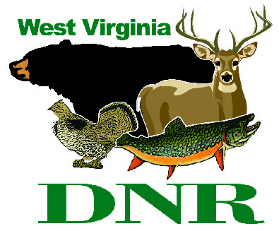 | West Virginia Division of Natural Resources www.wvdnr.gov  Earl Ray Tomblin, Governor Frank Jezioro, Director  News Release: Dec. 16, 2013  Facebook: WV Commerce - State Parks  Hoy Murphy, Public Information Officer 304-957-9365 hoy.r.murphy@wv.gov  Contact: Dave Bostic, Guest Services, Canaan Valley Resort State Park 304-866-4121 CanaanValleySP@wv.gov

Cold temperatures bring out the TF10s

at Canaan Valley Resort State Park

DAVIS, W.Va. - The TechnoAlpin TF10s are the big snow guns at the Canaan Valley Resort ski areas and December’s cold temperatures have them shooting snow in support of the new winter sports season. Weighing in at less than at ton and a length of almost 6 feet, the snow gun fleet at Canaan Valley is capable of creating and throwing snow for 200 feet or farther. If run for a 24 hour period at temperatures conducive for retaining snow, the snow guns can convert 250,000 gallons of water from on-site ponds to produce machine-made snow.
Natural snow and cold temperatures create good ski and tubing surface conditions. However, when snowfall is marginal but the temperature remains cold, using alpine equipment to produce snow builds a great snow base for a full season of downhill skiing, snowboarding and snow tubing.
“Canaan Valley is anticipating colder than normal temperatures and has started to augment natural snow accumulation for the ski season,” said Dave Bostic, managing director with Guest Services, the hospitality company that manages the facility operation at Canaan Valley.
Canaan Valley Resort ski beginner’s lift and lower mountain opened Dec. 7, followed by the opening of the tubing park and slopes Dec. 14. The resort posts ski updates to its website www.canaanresort.com and posts to Facebook and Twitter to announce ski dates and hours.
Canaan Valley Lodge is new and features 160 rooms with views of the valley and with many featuring fireplaces. The resort’s restaurant is open daily and features weekend buffets in a dining room that overlooks Canaan Valley. The Laurel Lounge also is located at the lodge and includes dining service featuring Wednesday Wings and Thursday Taco nights. The Buzztime Trivia Game site is popular with resort visitors and guests.
Season ski passes at Canaan Valley Resort are available. For more information about Canaan Valley Resort, visit www.canaanresort.com or call 304-866-4121.

About the TechnoAlpin TF10
The TF10 snow gun is a fully automatic, low-pressure type fan gun with an amazing projection capability. The quality of the snow is consistent over the entire area and slope preparation time is significantly reduced. Snow reliability is the number one criterion when it comes to choosing a winter sports destination.
Snow-making equipment helps to guarantee excellent winter recreation conditions. The indirect value of machine-made snow is also recognized by area businesses in the Canaan Valley region. Good snow attracts a higher volume of visitors to Canaan Valley area businesses that cater to and provide additional services supporting winter sport and holiday visitors.

**DNR**

Photos Courtesy of the West Virginia Department of Commerce.
TechnoAlpin TF10 snow guns at work at Canaan Valley Resort State Park

