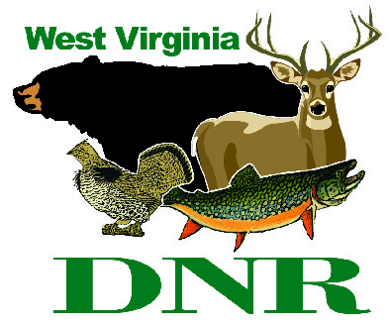 | West Virginia Division of Natural Resources www.wvdnr.gov  Earl Ray Tomblin, Governor Frank Jezioro, Director  News Release: Dec. 16, 2013  Facebook: WV Commerce - State Parks  Hoy Murphy, Public Information Officer 304-957-9365 hoy.r.murphy@wv.gov  Contact: Rob Gilligan, superintendent, Canaan Valley Resort State Park 304-866-4111 CanaanValleySP@wv.gov

Good Food at Canaan Valley Resort Awaits the “Tuckered”

DAVIS, W.Va. - Holiday buffets are special events at Canaan Valley Resort State Park near Davis, W.Va. Thanksgiving, Christmas Eve and Day, and New Year’s parties are big attractions. Thanksgiving features an expanded buffet, Christmas includes family and skiing options, and the New Year’s Eve packages are a choice of fine dining and lounge party for adults or a family themed park with a buffet and DJ.
Visitors to the Canaan Valley area come to play and stay. “Once guests ‘get tuckered’ from skiing, snowboarding or tubing, they tend to look for a good meal, perhaps a beverage, and a setting to relax and enjoy the indoor facilities at the resort,” said Rob Gilligan, superintendent at Canaan Valley and Blackwater Falls state parks.
Gilligan has restaurant operations at both parks, but there also is an array of dining options in the Tucker County area. “We invite visitors to either state park for meals and recreation, and we also encourage patronizing other eateries in the area,” Gilligan said. “Dining in the Tucker County area should be part of the experience when visiting.”

Dining Options at Canaan Valley Resort
Canaan Valley Resort features several food service options. “Our menus and setting include fine dining with beverage options as well as grab-and-go options for groups hitting the slopes or families looking for causal meals” said Dave Bostic with Guest Services, which operates Canaan Valley Resort.
The Hickory Dining Room is the main dining room at the new Canaan Valley Lodge. It is open year-round offering daily breakfast, lunch and dinner options. The Hickory Dining Room features a massive central fireplace and panoramic view of the valley.
The Laurel Lounge, also located at the lodge and conference center, is a full service bar with pub-style menu. The lounge offers guests an affordable menu with appetizer items, sandwiches and more. “Buzztime Trivia Challenge” is popular at the lounge. Wednesday is wings night and Thursdays feature tacos during evening hours. The Laurel Lounge also features live entertainment at various times throughout the year.
A Café’ just off the lodge registration area is a new addition. A quick mug of cocoa or cup of coffee and lighter fare is part of the different eatery options at the resort.
The Ski Area at Canaan Valley features the Bear Paw Food Court with cafeteria-style dining from December through March. Bear Paw features cold and hot subs, soups, hamburgers, hot dogs, chili, salads, snacks and pizza.
Quenchers Pub is a slope-side pub with a full-service bar and a variety of sandwiches and snacks. Quenchers’ relaxed décor and services are open December through March. Quenchers is a favorite setting for skiers “tuckered” from outdoor activities.
Golf Course Clubhouse Grill is open from April through November and offers a variety of breakfast and luncheon items. Skiers considering a return for golf play, clay shooting sport, hiking or biking in warmer months have this option for meals.
Learn more about Canaan Valley Resort dining and themed parties at www.canaanresort.com.
**DNR**

