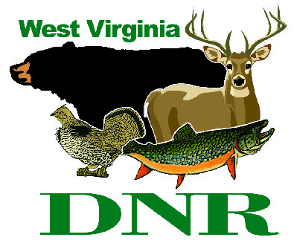 | West Virginia Division of Natural Resources www.wvdnr.gov  Earl Ray Tomblin, Governor Frank Jezioro, Director  News Release: Dec. 16, 2013  Facebook: WV Commerce - State Parks  Hoy Murphy, Public Information Officer 304-957-9365 hoy.r.murphy@wv.gov  Contact: Sissie Summers, State Parks Programming Coordinator  304-558-2764 Sissie.A.Summers@wv.gov

West Virginia State Park Gift Cards Have

“Something Extra” for the Holiday Season

SOUTH CHARLESTON, W.Va. – It’s that “Something Extra” time of year for purchasing West Virginia State Parks gift cards. Gift card purchases made online or by telephone order through Dec. 17, 2013, receive additional promotional discounts for the card recipient, or for the person who purchases the card.
For every $100 card purchased, the “Something Extra” cards are mailed with the West Virginia State Park gift card. Together, the plastic gift card and the paper “Something Extra” cards have a value totaling approximately $155, depending on use dates and if redeemed. Unlike the gift card itself, which can be used any time for all purchases and services at all state parks, “Something Extra” cards have expiration dates.
The “Something Extra” promotion is only offered on gift card purchases made online from now through Dec. 17, 2013, or by telephone order to 304-558-2764, (ask for Carol). There is no shipping or handling fee. Cards are mailed via US Postal Service.
“Gift cards convey to the recipient that a person knows you or your family interests,” said Sissie Summers of West Virginia State Parks. “The card becomes an experience when redeemed.”
West Virginia State Park gift cards can be used on lodging, dining, gift shops or other activities that charge a fee. In addition, each gift card purchase of $100 made online or by telephone order before Dec. 17 will receive up to eight “extras” such as “two for one” offers and other discounts at West Virginia State Parks and Forests. To place an order, visit www.wvstateparks.com and click “Gift Card Purchase” or call 304-558-2764, ext. 51828 (Carol).

About the eight “Something Extras!”
- 2-4-1 Ticket Price at Cass Scenic Railroad
Purchase a Whittaker Station Ticket the day of the trip and second person rides free. There are 95 dates in 2014 listed when this “extra” may be used.

- $25 off room rates at Chief Logan and Tygart Lake Lodges
Stay two or more nights and get $25 off standard rate with “extra” card.

- One-day Sled Run Pass at Blackwater Falls
Enjoy the Blackwater Falls State Park “magic carpet” at the Sled Run when using the “extra.” Not eligible during the “great cardboard sled race” Feb. 22, 2014.

- 18-hole Golf Play at One of Three Courses: Cacapon, Twin Falls or Pipestem
Rent a motorized cart and play 18 holes of golf for free in exchange for the “extra” card.

- Let’s Camp – night free at Little Beaver or Twin Falls Resort state parks.
Redeem “extra” card for second night free on first-come, first-served site rentals. Dates include most dates from opening day through the end of the traditional camping camping season in 2014.

- Room Rate Break at North Bend State Park Lodge
The “extra” card lists reduced room rates at North Bend State Park through 2014.

- Double Wheeeee! Aerial Tram Ride at Pipestem Resort.
With the “extra” card, two can ride the tram at Pipestem Resort State Park.

- Mystery Gift Card
Register online or by returning the “mystery card” to get a gift.

**DNR**

Photo Courtesy of the West Virginia Department of Commerce.
West Virginia State Parks gift card purchase of $100 or more made online or by telephone before Dec. 17 will receive “Something Extra” promotions worth up to an additional $55.

