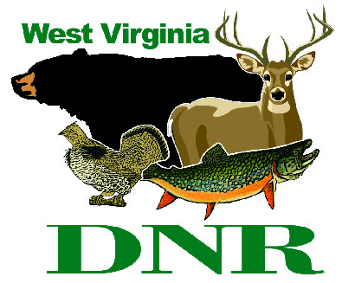 | West Virginia Division of Natural Resources www.wvdnr.gov  Earl Ray Tomblin, Governor Frank Jezioro, Director  News Release: Dec. 16, 2013  Facebook: WV Commerce – State Parks  Hoy Murphy, Public Information Officer 304-957-9365 hoy.r.murphy@wv.gov  Contact: Paul Redford, West Virginia State Parks District Administrator, 304-558-2764 dnr.parks@wv.gov

West Virginia State Parks Creates a “WV50” for January 2014

SOUTH CHARLESTON, W.Va. – WV50 is a “visit a state park” promotion to encourage friends, families and meeting planners to use lodge facilities at seven of West Virginia’s vacation state parks: Cacapon Resort, Chief Logan Lodge, Hawks Nest, North Bend, Pipestem Resort, Twin Falls Resort and Tygart Lake state parks. Room rates at these lodges are $50 for standard forest and mountain view rooms in January, excluding Jan. 17 and 18, and applied to one or more night rentals.
“Travelers already receive lower rates in winter months at these lodges. The ‘WV50’ is even more attractive,” said Paul Redford, district administrator with the West Virginia state park system.
Reservations can be made online using the WV50 reference or by calling the participating parks in advance and asking for WV50. The $50 rate includes weekends.
To learn more about West Virginia’s state parks, visit www.wvstateparks.com. Calls to 800 CALL WVA are greeted by a tourism travel counselor and will transfer your call to the respective state park requested.

**DNR**

