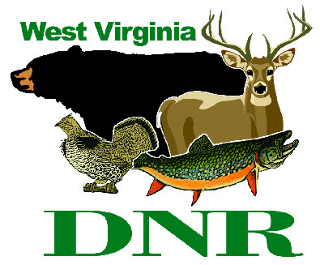 | West Virginia Division of Natural Resources www.wvdnr.gov  Earl Ray Tomblin, Governor Frank Jezioro, Director  News Release: Dec. 7, 2013  Facebook: WV Commerce - State Parks  Hoy Murphy, Public Information Officer 304-957-9365 hoy.r.murphy@wv.gov  Contact: Rob Gilligan, superintendent, Canaan Valley Resort State Park 304-866-4111 CanaanValleySP@wv.gov

Winter Rate Advantages at Canaan Valley Resort State Park

DAVIS, W.Va. - A variety of rate packages are available at Canaan Valley Resort to encourage all ages to get outside in the wintry months.
“Outdoor recreation is a four-season experience at Canaan, but when temperatures are colder and there is snowfall, winter recreation is exceptional at the state park,” said Lenora Testerman at Canaan Valley Resort. Testerman keeps the resort website active with overnight packages, event, and special day rate information at www.canaanresort.com. Special rates are available daily, excluding Dec. 26- 31, 2013; Jan. 18- 19, 2014; and Feb. 15- 16, 2014.
Other rate deals and discounts at Canaan Valley Resort in 2013/2014 include:

Military Discounts
With presentation of military identification, active or retired military personal and immediate family receive a 50 percent discount midweek on a single day ski lift ticket on non-holiday dates, and 10 percent on weekend or holidays during the winter. Tubing park ticket prices are reduced 10 percent for any day for military personnel. A 15 percent discount is extended to active or retired military personnel for guest rooms and cabin/cottage rentals on non-holiday nights.

Students Daze
A student/faculty lift and rental rate is available for ski lift tickets and ski/snowboard equipment rentals with valid college identification. Students Daze rates are Monday – Friday through the 2013-2014 ski season, not including Dec. 26-31, 2013. Lift tickets are $20; lift/ski rental is $30, and lift/snowboard rental is $40.
Snow Busters
Snow Busters are generally created on short notice and the resort uses Twitter, Facebook and the website to spread the word. Visit www.canaanresort.com to subscribe to Ski News, to follow tweets or to become a Facebook friend.

Midweek Promotions
Special rates are available daily with the following exceptions: Dec. 26-31, 2013; Jan.18-19, 2014; and Feb. 15-16, 2014.

Food Bank Mondays
Food Bank Mondays combine winter recreation and a sense of community. Lift tickets are $15 for skiers who donate a non-perishable food item on Mondays.

BOGO Tuesday
Two choices of the “buy one, get one” promotion make Tuesdays popular at Canaan Valley: buy one ski lift ticket at regular rate, receive one of equal or lesser value free; or, buy one tubing ticket at regular price, receive one of equal value free. Tubing tickets include the tube rental.

West Virginia Wednesdays
Residents of the state of West Virginia and neighboring Garrett County, Md., can ski Canaan Valley Resort on Wednesdays at a discounted rate. The West Virginia Wednesdays discount is extended to state residents with valid identification. Lift tickets are $20; lift/ski rental is $30, and lift/snowboard rental is $40.

Heroes Day Thursday
Individuals who provide service or protection to our country (military, firefighters, EMS, or police officers with valid ID) are extended a $20 lift ticket price of $20; lift/ski rental of $30, or lift/snowboard rental or $40.

Snow Days
When school is canceled due to snow conditions, Canaan Valley encourages youth and school personnel to hit the slopes and be active outdoors. All students, faculty and parents are extended reduced rates: lift ticket $15; lift/ski rental $20; lift/snowboard rental $30, or two-hour Tubing Park session $12.

**DNR**

