MERCY SHIPS TO BUILD WORLD’S LARGEST CIVILIAN HOSPITAL SHIP
Deal Doubles the Capacity to Deliver Free, World-Class Health Care

PHOTOS/CAPTIONS: Mercy Ships - CSIC Contract Signing - Beijing China - December 2013
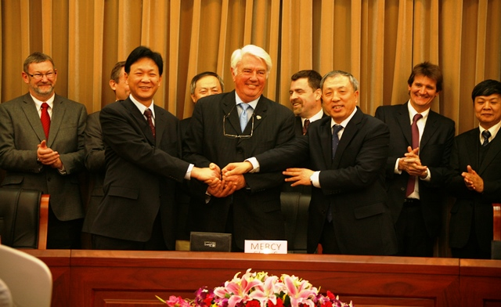
NEWSHIP_CHINA_HANDSHAKE_14122013_lo (photo thanks to CSIC)
From L – R: Front row: President Hu Xiang (Tianjing Xingang Shipyard), Don Stephens, President / Founder (Mercy Ships); President Xu Ziqiu (CSOC)
Back row: Jim Paterson, Sr VP International Operations (Mercy Ships); Per Westling, MD (Stena RoRo); Dong Qiang, VP (CSIC); Roland Decorvet , CEO (Nestle China); Gilbert Walter (BRS); Gao Xuehu, Chairman (Tianjing Xingang Shipyard).
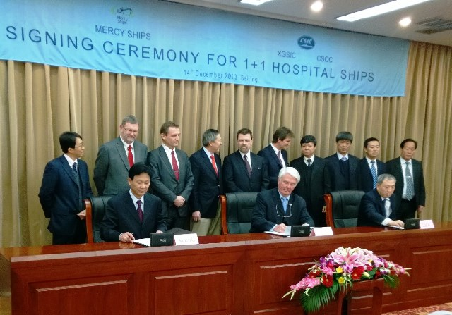
NEWSHIP_CHINA_SIGNING_14122013_lo (photo thanks to CSIC)
Front row: President Hu Xiang (Tianjing Xingang Shipyard), Don Stephens, President / Founder (Mercy Ships); President Xu Ziqiu (CSOC)
Back row: Ken Zhang (Asia Shipping); Jim Paterson, Sr VP International Operations (Mercy Ships); Per Westling, MD (Stena RoRo); Dong Qiang, VP (CSIC); Roland Decorvet , CEO (Nestle China); Gilbert Walter (BRS); Gao Xuehu, Chairman (Tianjing Xingang Shipyard); Yu Kexuan, VP (Tianjin Xingang Shipyard);Wang Xinqi, Chief of Marine Product Management Section Production and Business Department (CSIC) and Jin Baogang, Vice General Manager of Shipbuilding & Trading Dept.1 (CSOC).
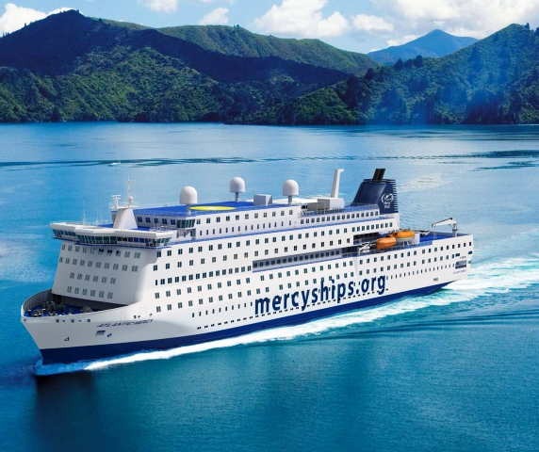
Mercy Ships, the hospital ship charity, has announced that contracts have been signed for construction to begin in Asia on what will be the world’s largest civilian hospital ship. www.mercyships.org

