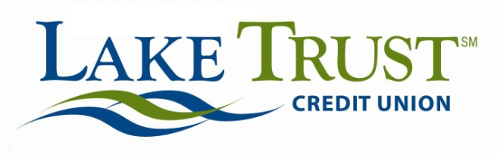

|  |  |
| --- | --- |
| ***News Release***  FOR IMMEDIATE RELEASE: November 21, 2013 | FOR MORE INFORMATION CONTACT:  Lori Anderson  734.626.0319  [landerson@laketrust.org](mailto:landerson@laketrust.org)  Keith Koppmeier  248.990.6994  [kkoppmeier@laketrust.org](mailto:kkoppmeier@laketrust.org)  Website: [laketrust.org](http://laketrust.org/) |

Lake Trust Credit Union’s Lake-to-Lake Food Drive provides 20,000 meals to Local Families

***Lansing, Michigan* –** Lake Trust Credit Union’s 2nd annual Lake-to-Lake Food Drive is a success, collecting **over 24,000 pounds of food for Michigan families**. Food collected is donated to local food banks and will provide **20,000 meals for families** in need this holiday season.

The event had a great start with a **400 turkey donation from FireKeepers Casino Hotel** and **recognition at both the state and national level for CUNA’s Dora Maxwell Social Responsibility Award**. Those, in combination with an overwhelming amount of support from the Credit Union’s communities and members, helped to make the Food Drive a success for its second year in a row.

“Team Lake Trust couldn’t be more pleased than to be able to make this difference for so many Michigan families,” said David Snodgrass, Lake Trust Credit Union President and CEO. “We can’t thank our members, communities and partners enough. What we’ve come together to do here will be truly valuable for so many during the holidays.”

Food collected was distributed to a number of local food banks including the Greater Lansing Food Bank, Feeding America West Michigan Food Bank, Food Gatherers, and Gleaners Community Food Bank of Southeastern Michigan. In addition, Two Men and a Truck, The Greater Brighton Chamber of Commerce and FireKeepers Casino Hotel were invaluable partners in this community effort.

“We want to thank our members, communities and partners, who really pulled together to make this meaningful contribution for these families,” said Keith Koppmeier, Lake Trust Credit Union director of corporate responsibility. “Being able to give back to our communities and the families in them is so much of what we work for all year.”

To learn more about the Lake-to-Lake Food Drive, visit [laketolakefooddrive.org](https://laketolakefooddrive.org/).

The Lake Trust Credit Union Foundation is a **501(c)(3) dedicated to making a difference by volunteering time and resources to Michigan.** The Foundation’s mission is to bring people and organizations together to create strong, diverse, vibrant neighborhoods through sponsorships, grants and Team Lake Trust volunteerism. Learn more at laketrust.org

Lake Trust Credit Union is Michigan’s fourth largest credit union with branches stretching from Lake Michigan to Lake Huron and Lake Erie. With more than $1.5 billion in assets, Lake Trust provides over 157,000 members with best-in-class products and offers individualized, trust-based member service. As a community-based credit union, Lake Trust strongly believes in supporting its communities and participates annually in Komen for the Cure® in Ann Arbor and Lansing, as well as nearly 100 events and causes annually throughout Michigan. Membership is open to anyone within its 35-county service area. Follow Lake Trust on Twitter @laketrust. Lake Trust is also on [Facebook](https://www.facebook.com/LakeTrustCreditUnion)