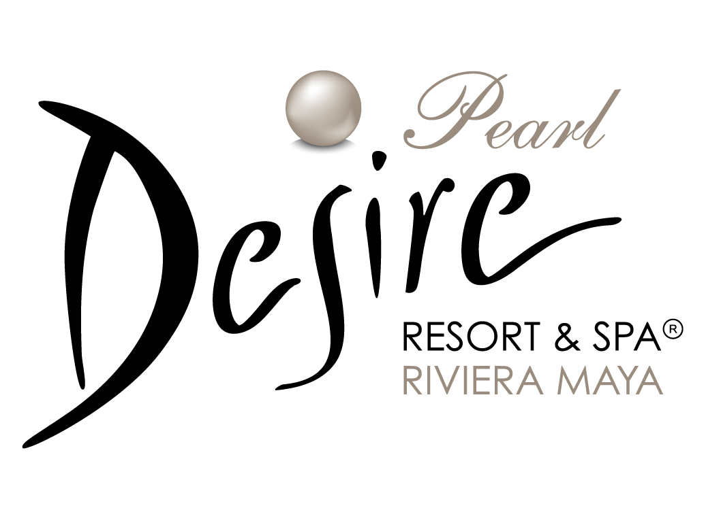

For immediate release.

Desire Pearl Resort & Spa Presents: The Fantasy Menu.
Cancun, September 17th, 2013, Desire Pearl Resort & Spa, the couples only property in the Riviera Maya, is so proud to present a brand new menu of fantasies, that have been designed with guests pleasure on mind.

Following all guests suggestions and thoughts, Desire Pearl have come up with 7 ideas that will surely fulfill the fantasies of our guests once considered forbidden even at Desire Resorts. Choose one per day if that’s your wish, and enjoy the most deliciously erotic moments more than ever at the Desire Resort, a clothing optional hotel.

Gathering special ingredients that include whipped cream, our Aphrodite terrace, and a pole dance lesson, for instance, Desire Pearl Resort have created a menu of erotic fantasies that couples can enjoy with their partner and/or with their friends.
So if there is a fantasy people haven’t fulfilled yet at Desire Resort, now, they have to come one more time and experience the new fantasy menu. Now, guests don’t only have to imagine having an intimate dinner, desserts and sex outdoors, because Desire Pearl will make it happen if that’s our guest’s desire.

Having fantasies is what keeps the passion alive and Desire Pearl Resort & Spa will bring them all to life, stimulating our guests senses like never before so that the only desire left will be to come back soon to Desire Pearl, the couples only resort.

Visit:
http://dsr.re/18

Contact:

Gloria Otero
Guest Service Manager
guest.pearl@desireresorts.com
Tel: 52 998 872 8063 ext: 226

