The 2014 Top 15 Teasers Countdown


I thought it would be fun to make my 2014 Teaser List a countdown as that seemed appropriate going into the new year. This list is not comprehensive and there are other initiatives that are underrway or about to get underway, but I chose the 15 that I think will have the greatest impact, are currently underway and have a short delivery timeline.

I anticipate the release of all of these initiatives early in 2014 and if they made my list it is because I believe they will have significant impact on the growth of YOBSN and your personal success.

So here is my list that probably only I am the only one who agree with the order. No feedback or harsh comments on my totally subjective choice of the order, please!

Number 15 - in 15th spot I am putting the Discovery Adventure upgrade. With new graphics and functional matching prizes and on the mobile platform it will be a big draw for our Free Members

Number 14 - Smart Phone Hero (title may change) introduces a new type of product for YOBSN, digital video training systems. I see this as a nice revenue stream for the YOBSN Owner, it will be a typical impulse buy type of item for your free visitors.

Number 13 - One of the best tools ever created to easily bring people to become YOBSN Owners with no selling was the Smart Media Magazine. YOBSN WorldWide Magazine is the new updated replacement for the highly successful SM Magazine and brings the latest answers to the question, "What is YOBSN?"

Number 12 - In the twelfth spot I am highlighting another essential prospecting tool. The YOBSN Information Centre will instantly become the place that you will send your prospects to find out about and buy their own YOBSN. The YOBSN Information Centre will be our first foray into using the 1 Page SuperSite format in our own sales systems. I predict this will become the hub of all YOBSN sales activity online.

Number 11 - Memory Lane is now becoming a reality and on mobile, no less! This and Number 10 on this list represent our formal entry into real Edutainment Games across all platforms. Memory Lane is a memory enhancing tool that should be effective across all age groups.

Number 10 - Number Muncher is the other entry into the Edutainment Category. This is a fun entry into number mastery for the younger YOBSN visitors. Designed to get parents involved in their children's education.

Number 9 - The ninth position is held by another new digital video training system (dvts) Trick Photography Hero. I think this got 9th position just because I am so excited to learn all of the tricks the experts have loaded into its training. This should be a steady revenue stream for YOBSN Owners.

Number 8 - Run Bunny Run! The mobile gaming market is trending like crazy and family friendly games like Run Bunny Run! are going to be in high demand. With in game purchases and Social Point Rewards this game is bound to be very popular with both YOBSN Professional Plus Package Owners and their Free Members.

Number 7 - The 1 Page SuperSite represents a high commission product that fits in a rising need on the Internet right now. Typical web sites are getting old and are just not having the impact they used to. The 1 Page designed represents the leading edge of new site design and today's online marketer does not want to become a web site developer. This site is professional assembled and hosted, but personalized to the owner and incredibly inexpensive to deliver. This is a product that will build momentum in 2014 as the word gets out.

Number 6 - 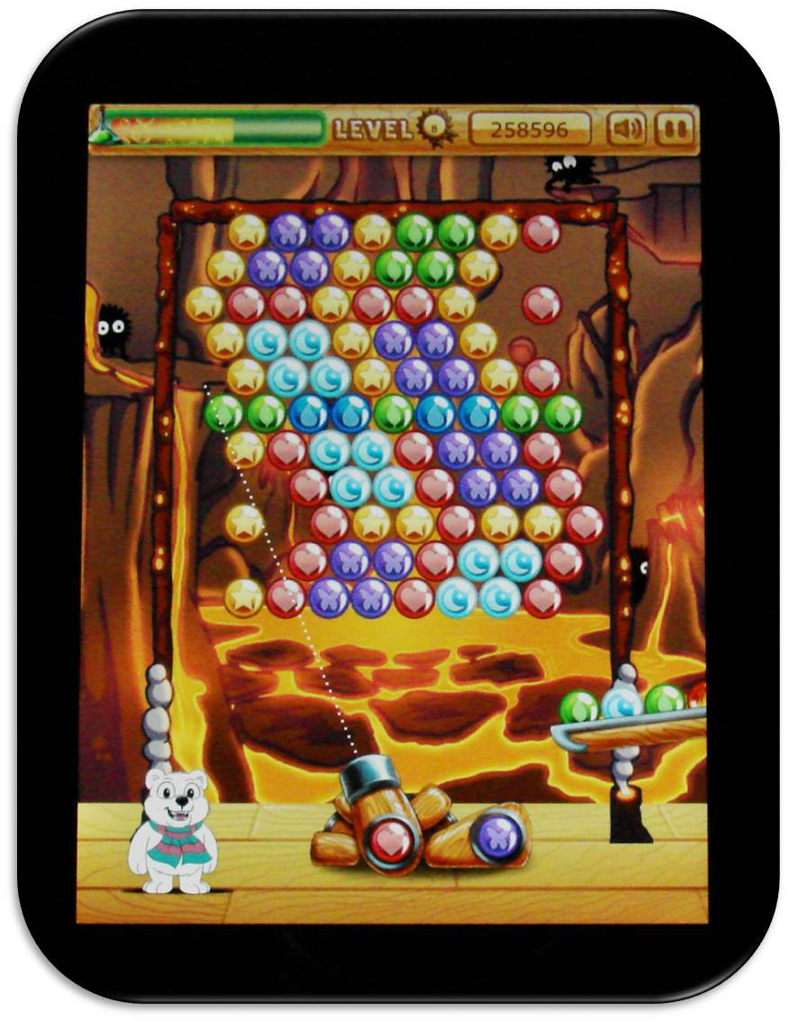Bubble Champion is rapidly on its way to becoming a mobile game hit and we have not even added the sound effects and music yet! I think this will be the best game of its type on any platform. Of course, the YOBSN Owner will enjoy the revenue stream from the in-game purchases. This could be the surprise winner of 2014 bringing in huge numbers Free Members coming to YOBSN wanting to play and thereby creating a great revenue stream for the YOBSN Owner.

Number 5 - The Social Rewards area is very near and dear to the heart of YOBSN Members. They have been waiting for a long time for this area to open. This is the highest area of potential fraud risk to YOBSN. The company will be introducing the many features of this area in phases and making sure the security is solid before adding more. But you will soon see tangible rewards that Social Points holders will be able to spend their points on.

Number 4 - I put the new YOBSN Sizzle Video into 4th position because I know how much impact a video like this can have in driving and closing leads for YOBSN. The implementation of this new video which is in production now is one of the keys to YOBSN Owner success.

Number 3 - The new YOBSN Professional Plus Package get the third place slot based on the impact it will have on YOBSN and on the revenues of YOBSN Owners. I am comfortable that this will become the premier package that the top YOBSN Owners will be selling. They will ge more revenue and more bonuses than have ever been available before. Of course this package is driving sales right now by allowing all Professional Package owners a free upgrade.

Number 2 - Woo Hoo! It's real! YOBSN Owners are going to get a percentage of every sale made by their free members in 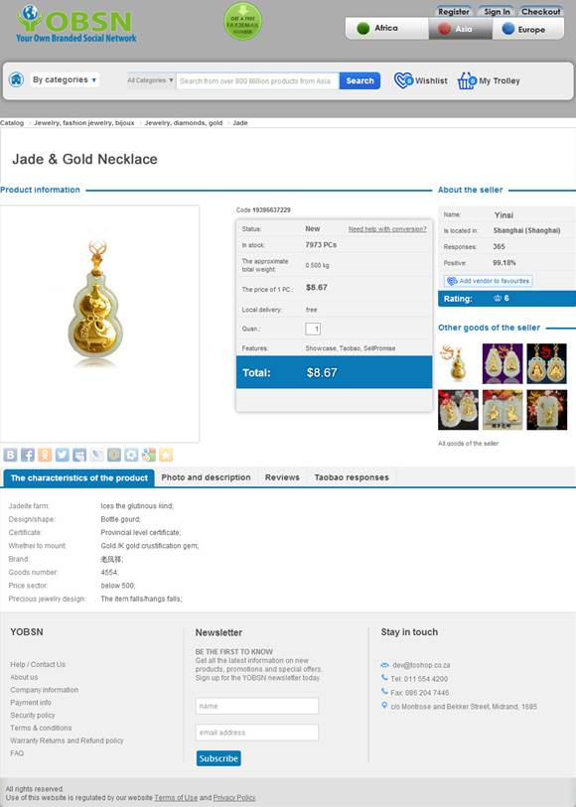the YOBSN Global Shopping Experience. As they peruse the over 800 million products in the YOBSN branded online catalogs in foreign countries. They will have guides to help them with their shopping. There will be no hidden costs or duties to shipping. When the customer checks out they know exactly what it will cost delivered to their door. The YOBSN Global Shopping Experience will accomplish 2 key things. One it will drive free membership to your YOBSN because they will be so excited about this unique shopping experience that they can only get in YOBSN. And two, it will create an ever growing revenue stream for the YOBSN Owner. More details will be forthcoming.

Number 1 - And no surprise the Number 1 spot on my list goes to YOBSN Mobile. This technology changes the whole face of Social Networking and is another amazing first. Having YOBSN "in your pocket" will fundamentally change our business. YOBSN is already the first revenue sharing personalized social network and soon will be the first to be 100% mobile ready as well. Can you say "disruptive technology"?
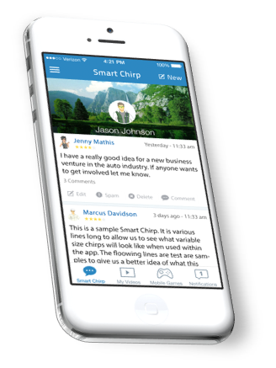

We are doing our part to provide you with the most amazing tools to succeed in your business and change your world for the better that we think are available anywhere.

Now we need you to do your part and use these tools to spread YOBSN throughout the world and revitalize lives, making the World a Better Place, now and into the future.

