

ANKAMA LAUNCHES KICKSTARTER TO CROWDFUND ENGLISH VERSION OF AWARD-WINNING ANIMATED TV SERIES WAKFU

Anime fans have the chance to help an English-dubbed version of the acclaimed anime series become a reality

ROUBAIX, FRANCE – January 21, 2014 – Leading international online game, anime and comic-book publisher Ankama launched its first ever Kickstarter campaign for an animated series. The goal of the campaign is to create an English-language version of the award-winning WAKFU animated TV Series for Blu-Ray and Video On Demand (VOD) release. Ankama has chosen Kickstarter in order to intimately involve fans in making its dream a reality, and to ensure it delivers the highest production quality possible.

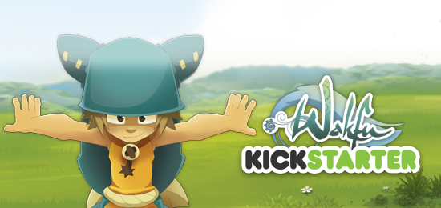

For full details on the Kickstarter campaign, including the rewards available and the stretch goals, click here.

Watch the trailer at the link here to get a first taste of WAKFU in English and meet one of its most charismatic characters.

Assets available for download and publication here: Trailer and Screenshots

The WAKFU animated series was first shown on French national TV (Channel3) in 2008, with 52 episodes broadcast to date and an additional three special episodes currently in production. The series and its creators have won numerous awards including International Studio of the Year at the 2010 Cartoons on the Bay Awards in Italy. In addition, Season Two of WAKFU was named best non-Japanese animated series of 2011 by the readers of French magazine, Animeland. WAKFU is also a massively multiplayer online role-playing game (MMORPG) and a series of comic books. Click here for more information on the WAKFU MMORPG game.

“The trans-media approach is in Ankama’s DNA, but so far we have only been able to deliver the full immersive WAKFU anime and game experience in French-speaking countries. We very much want to offer the same opportunity to our English-speaking community,” said Olivier Comte, Managing Director and Chief Operating Officer at Ankama. “A high-quality English adaptation needs a big commitment, so we’re asking anime fans everywhere to support the Kickstarter campaign to make it happen. With your help, the English-dubbed version can reach the level of quality every fan deserves.”

The WAKFU Kickstarter campaign offers a range of reward packages available to backers, including one ultimate package which offers fans the unique opportunity to voice one of the characters in the anime. Stretch goals include subtitles in English and Spanish, dubbing of special episodes, dubbing of the entire second season, and more.

WAKFU’s adventure begins in Emelka, a small village lost in the woods. Yugo, a 12-year-old boy, lives in the village inn run by his adoptive father, Alibert. One day, Yugo discovers he has mysterious powers, an unexpected event that marks the beginning of a new life for him. Alibert tells him that he isn’t his real father and that he must leave on a quest to find his true family. Accompanied by his loyal companions, Yugo begins an epic adventure, during which he and his friends will discover that the fate of the entire World of Twelve rests on their shoulders.

Ankama’s goal is to deliver trans-media entertainment of the highest possible quality to its community.

For more information about WAKFU, please visit www.wakfu.com/en/mmorpg, and for Ankama, visit www.ankama-group.com.

About WAKFU
WAKFU is a trans-media experience comprising an animated series, online and console video games, and comic books. Each adventure is an original creation which can be lived separately, although the experience is richer if you explore various media! WAKFU transports its fans into the same magical, humorous universe as DOFUS, whilst adding notions of ecology and citizenship. For more information, please visit the official WAKFU website at www.WAKFU.com. Follow us on Facebook: www.facebook.com/wakfu

About ANKAMA
Ankama is an independent French group and a leader in the entertainment industry that builds its development around a trans-media strategy: online games, animation, publishing, press, music, merchandise, toys, games for next-generation consoles and mobile devices. Ankama develops its universes through all of these media to create a complete and immersive narrative experience. www.ankama-group.com

Florence Di Ruocco
Press officer
fdiruocco@ankama.com

2014 © Ankama All rights reserved
Press Release 2014 © Ankama. All Rights reserved.

