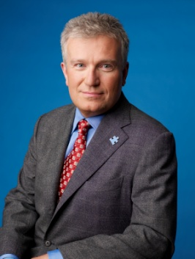**DUNCAN L. NIEDERAUER**

**CHIEF EXECUTIVE OFFICER, NYSE**

Duncan L. Niederauer is Chief Executive Officer of NYSE. During his tenure as CEO, Mr. Niederauer is proud to have overseen the transformation of the company into an innovative, globally integrated organization with a high-tech, high-touch focus. Prior to his current position, Mr. Niederauer was President and co-Chief Operating Officer of NYSE Euronext with responsibility for U.S. cash equities.

Before joining NYSE Euronext in April 2007, Mr. Niederauer was Managing Director and co-Head of the Equities Division Execution Services franchise at Goldman, Sachs & Co. His career at Goldman Sachs spanned 22 years.

Mr. Niederauer has served on the board of Archipelago Holdings, LLC and Colgate University, and now serves on the board of Operation Hope, The American Ireland Fund and the Congressional Medal of Honor Foundation. His current affiliations include G100, Chief Executive 50, British-American Business Council International Advisory Committee, Partnership for New York City, Committee Encouraging Corporate Philanthropy, Shanghai International Financial Advisory Committee, Museum of American Finance, Pace University President’s Council and Fundação Dom Cabral in Brazil.

He earned an MBA from Emory University and a BA from Colgate University. He and his wife, Alison, led the Newmark School’s “Destination of Promise” campaign, which built a state of the art school for children with autism and related disabilities in Scotch Plains, NJ. They have three children and reside in New Jersey.

**About NYSE Euronext**

NYSE Euronext (NYX) is a leading global operator of financial markets and provider of innovative trading technologies. The company's exchanges in Europe and the United States trade equities, futures, options, fixed-income and exchange-traded products. With approximately 8,000 listed issues (excluding European Structured Products), NYSE Euronext's equities markets — the New York Stock Exchange, NYSE Euronext, NYSE MKT, NYSE Alternext and NYSE Arca — represent one-third of the world’s equities trading, the most liquidity of any global exchange group. NYSE Euronext also operates NYSE Liffe, one of the leading European derivatives businesses and the world's second-largest derivatives business by value of trading. The company offers comprehensive commercial technology, connectivity and market data products and services through NYSE Technologies. NYSE Euronext is in the S&P 500 index. For more information, please visit: [http://www.nyx.com](http://www.nyx.com/).