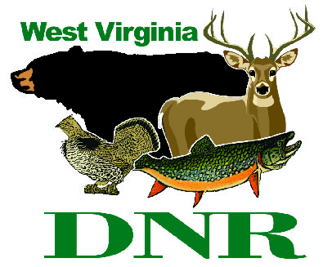 | West Virginia Division of Natural Resources www.wvdnr.gov  Earl Ray Tomblin, Governor Frank Jezioro, Director  News Release: Jan. 31, 2014  Facebook: WV Commerce - State Parks  Hoy Murphy, Public Information Officer 304-957-9365 hoy.r.murphy@wv.gov  Contact: Sissie Summers, State Parks and Recreation Section 304-558-2764 Sissie.A.Summers@wv.gov

February yields “Polar Night Rewards” for State Park lodge visitors

SOUTH CHARLESTON, W.Va. - State park lodges in West Virginia are open year-round, including winter months when temperatures plunge to freezing or below outside.
“Inside our lodges, park visitors will find fireplaces, restaurants serving hot meals, and comfortable rooms for a winter retreat,” said Dee Pack, desk clerk at Chief Logan Lodge. Pack, like other state park lodge desk clerks, has come up with a reward for visiting in the winter: “Polar Night Rewards.”
“The promotion is a certificate issued to overnight guests staying two or more consecutive nights in February at a participating lodge for a free night’s stay,” said Rita McAllister at Twin Falls State Park
The Polar Night Reward free overnight stay may be redeemed midweek (Sunday through Thursday) in April 2014 or for a midweek night from Aug. 18 through Sept. 30, 2014, as available.
“The ‘reward’ for staying during in February is to be used during a part of the year when the weather is warmer,” said Kristi Steed at North Bend State Park.
Participating parks are Twin Falls, Tygart Lake, Pipestem, Hawks Nest, Blackwater Falls, Chief Logan Lodge and Cacapon state park lodges. Many lodges offer express breakfast with overnight stays.
Whether it is cold or warm outside, West Virginia’s state parks are open and encourage visits. Polar Nights, spring midweek cabin specials and other promotions and rate packages are posted frequently on the state park websites and on www.wvstateparks.com. Individuals who subscribe to “Join Our Newsletter” will receive emails about discounts, events or specials. Subscriber emails are not sold or shared and anyone can unsubscribe at any time.
To learn more about all of West Virginia’s state parks and forests, accommodations, services and outdoor recreation, visit www.wvstateparks.com. Visit and support a state park by staying overnight, enjoying a meal, camping or playing a round of golf in 2014. To receive state park updates via Facebook, click “Like” at www.facebook.com/ wvstateparks.

**DNR**
Photo courtesy West Virginia Department of Commerce
Pipestem Resort State Park is one of several West Virginia state park lodges offering “Polar Nights Rewards” in February.

