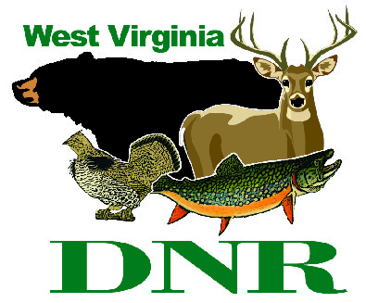 | West Virginia Division of Natural Resources www.wvdnr.gov  Earl Ray Tomblin, Governor Frank Jezioro, Director  News Release: Jan. 31, 2014  Facebook: WV Commerce - State Parks  Hoy Murphy, Public Information Officer 304-957-9365 hoy.r.murphy@wv.gov  Contact: Ken McClintic, Supt., Holly River State Park  304-493-6353 hollyriversp@wv.gov

It’s Holly by Golly in 2014

West Virginia state park recovers from 2012 storm damage

HACKER VALLEY, W.Va. - Holly River State Park is resilient. Two major storms in less than six months – a derecho followed by Superstorm Sandy in 2012 – put the park squarely back into the 18th century by extinguishing electricity and wreaking havoc on the park’s infrastructure, resulting in several months of closure. However, Holly River State Park is back on track in 2014 and welcomes friends to return and invites newcomers to discover one of West Virginia’s most loved state parks.
Located at Hacker Valley in Webster County, the park opens cabin rentals to the public for vacation and recreational use April 4 through Nov. 30, 2014. Holly River’s 10 cabins are constructed of natural stone and logs. They are located in a peaceful setting of rhododendron and sturdy hemlock, through which flows a small stream feeding Laurel Fork.
“The cabins at Holly River are unique. Reservations are brisk so far,” according to Ken McClintic, park superintendent. “People are getting the word that we are open again and we hope they continue to spread the word. Like good friends, patrons return to Holly River year after year.”
The campground at Holly River has been restored and will reopen in April. Reservations are taken for site rentals from Memorial Day through Labor Day weekends. A reservation form is posted on the park website www.hollyriver.com under the “Camping” tab.
Campsite reservations are taken in written form beginning Feb. 15. A standard campsite fee at Holly River is $23 and includes electricity. Senior campers age 62 and older receive the senior discount rate. The phone number at Holly River is 304-493-6353 or email hollyriversp@wv.gov.
Trout stocking at Holly River occurs in February and March on Laurel Fork and Fall Run. Stockings are conducted by the Division of Natural Resources. Fall Run is stocked once each month February through May and Laurel Fork is stocked once in February and once every two weeks March through May. Visit wvdnr.gov, “Trout Stocking,” for more information about WVDNR’s trout stocking schedules.
To learn more about Holly River State Park 2014 opening dates, special accommodation offers and the restaurant opening, subscribe to the electronic WV State Park newsletter. Click “join our newsletter” on www.wvstateparks.com. To receive state park updates via Facebook, click “Like” at www.facebook.com/ wvstateparks.

**DNR**
Photo courtesy West Virginia Department of Commerce
Cabins at Holly River State Park open for rental April 4, 2014.

