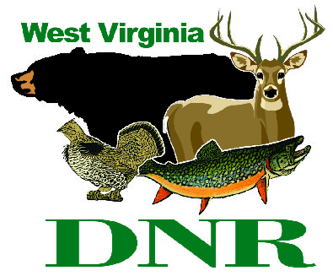 | West Virginia Division of Natural Resources www.wvdnr.gov  Earl Ray Tomblin, Governor Frank Jezioro, Director  News Release: Jan. 31, 2014  Facebook: WV Commerce - State Parks  Hoy Murphy, Public Information Officer 304-957-9365 hoy.r.murphy@wv.gov  Contact: Rob Gilligan, Supt., Blackwater Falls State Park  304-259-5216 BlackwaterFallsSP@wv.gov

MARCH! Madness at Blackwater Falls Lodge

DAVIS, W.Va. - A single Washington ($1) creates a three-night deal in March 2014 at Blackwater Falls State Park Lodge. Park Superintendent Rob Gilligan encourages folks to leave winter behind and march into spring in the month of March.
“Winter weather is unpredictable in March. Sledding could be great or we may have fair weather depending upon Mother Nature,” Gilligan said. “Regardless of weather or predictions, we are encouraging people to visit and enjoy the outdoors by authorizing a March rate break at Blackwater Falls Lodge.”
Midweek rates with advance reservations in March are 20 percent off for stays of two consecutive nights, Sunday through Thursday. Gilligan’s March Madness kicks in when adding an additional night to the stay at the price of one dollar. Friday and Saturday night rates are standard, but extending the weekend stay to include Sunday is also a $1 rate.
Blackwater Falls State Park is located in Tucker County in Davis. The four-season park is near Canaan Valley Resort. Blackwater Falls features a guest lodge with indoor swimming and fitness center, restaurant and game room, 39-vacation cabins, campground, sledding, nature center and hiking. The iconic waterfall at Blackwater Falls State Park is recognized nationwide. For more information call 304-259-5216 or visit www.blackwaterfalls.com
**DNR**
Photo courtesy West Virginia Department of Commerce
March Madness comes to Blackwater Falls State Park with a third night lodge overnight stay at $1 rate.

