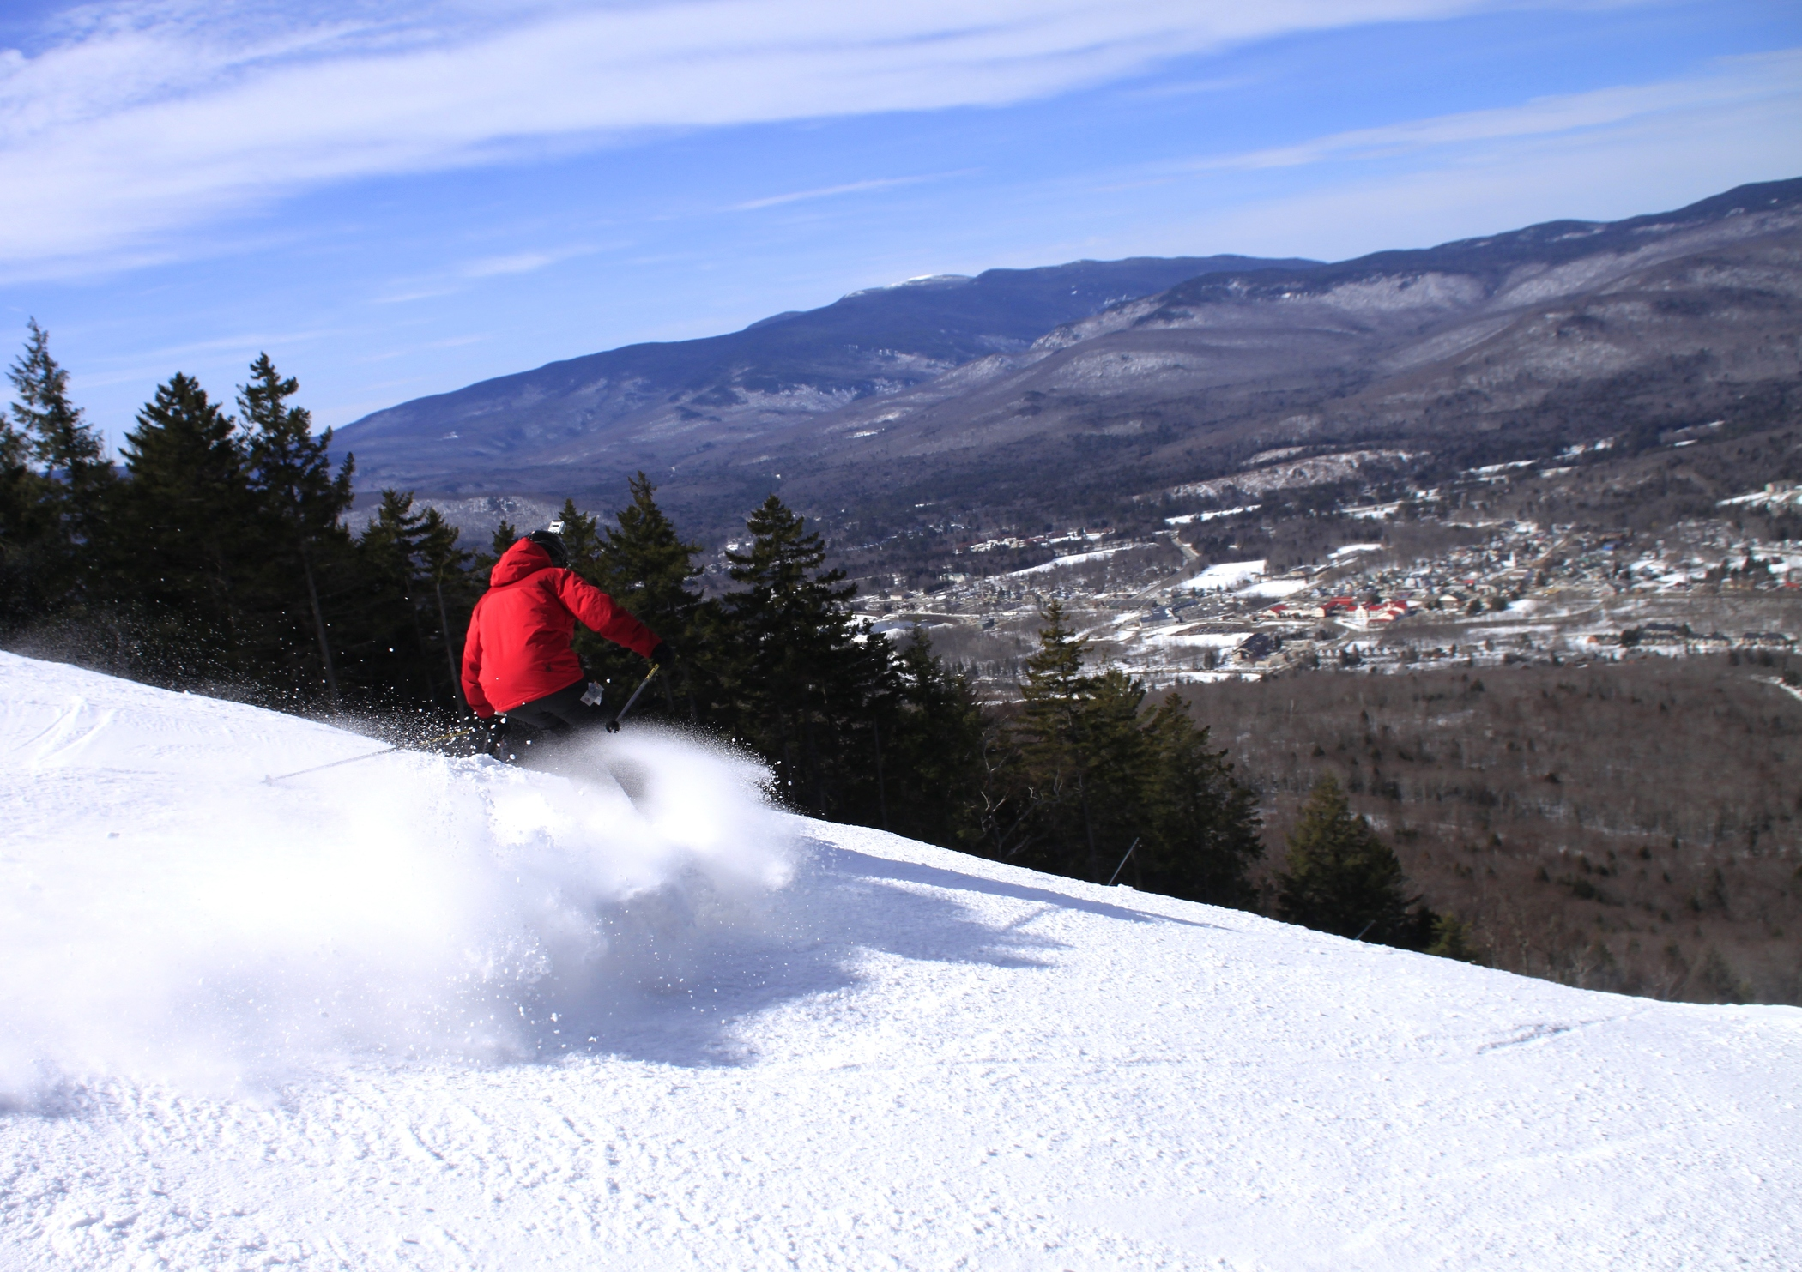
To Help You Plan Your Vacation to Lincoln-Woodstock…

Alpine Adventures
Loon Mountain
Cannon Mountain
Winter Festival at Jean’s Playhouse
Muddy Paw Sled Dog Kennel
SledVentures
Outback Kayak

For more information about lodging, dining, or to get your free vacation planning guide:
Website: www.lincolnwoodstock.com
Email: info@lincolnwoodstock.com
Call: 603-745-6621

