Press Release
Las Vegas’ Own Bellina Rebelle Swimwear Launches in Sports Illustrated Swimsuit Issue
Time Warner’s Magazine Features Original Swimsuit Designs by Newly Launched Swimwear Line. The Company Showcased Several Suits in the 50th Anniversary of its Popular Swimsuit Issue and Online.
LAS VEGAS, NV (February 18, 2014) – The 50th Anniversary Sports Illustrated Swimsuit Issue includes innovative swimwear company, Bellina Rebelle. The print and online versions of the popular issue feature several pieces of the inaugural line of customizable swimwear.
“The only way to describe it is amazing. We submitted a few suits and we’re thankful to be featured in such a commemorative issue,” says Brittany Kosmala, Founder of Bellina Rebelle.
Designed for women with an active lifestyle, the Bellina Rebelle brand stands for creativity and individuality. Made with the highest quality and durable materials, the suits can be customized with colorful straps, a weather resistant line of jewelry and a variety of top and bottom options. Bikini lovers can create their own swimsuit designs in just minutes.
The edgy look captures the spirit of the company founder and designer. Kosmala says, “With our designs, we want to show the Bellina Rebelle attitude and live up to our motto… looking good, behaving badly.”
The unique brand name is comprised of a mix of the Italian word bellina and the French word rebelle, translated in English, Beautiful Rebel.
To learn more about Bellina Rebelle, visit www.bellinarebelle.com.
About Bellina Rebelle Swimwear
Founded in 2012, Bellina Rebelle Swimwear was started by local designer Brittany Kosmala, whose vision for creating unique and fashionable designs defines the company. Over the past two years, Bellina Rebelle has been perfecting designs and setting up commercial manufacturing operations. Today, the company plans to distribute swimwear nationally to beach resort locations.
Facebook: www.facebook.com/BellinaRebelle
Twitter: @BellinaRebelle
Google Plus: https://plus.google.com/+Bellinarebelle/posts

Media Contact:
Chris Angelo
Propulsion Marketing
702-630-2316
chris@propulsion-lv.com
# # #

Las Vegas’ Own Bellina Rebelle Swimwear Launches in Sports Illustrated Swimsuit Issue

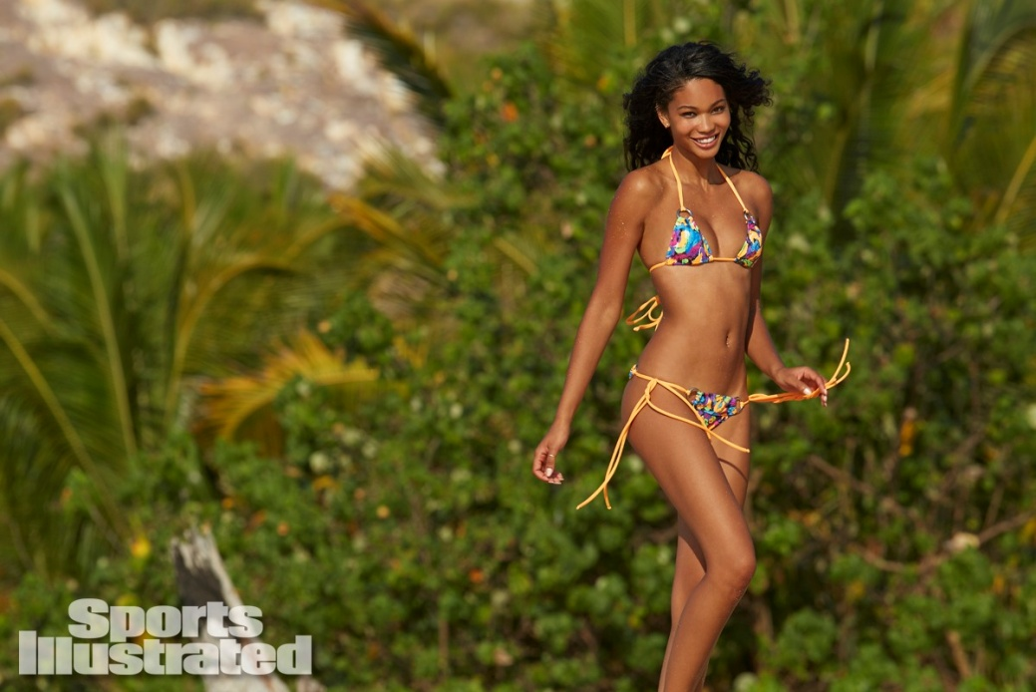
Like, totally tubular dude!
Top: $49 Bottom: $49
This gnarly 80’s surfer inspired throwback was taken to the next level exclusively for Sports Illustrated Swimsuit Edition and featured on SI.com with model Chanel Iman.
The stretch cotton material is a multi-neon colored abstract print in the sexy Bellina Rebelle Mini Tri top and Back Banded Thong. With silver colored rings and matching neon orange string ties, this suit will definitely take you back in time.



Victoria
Top $49 Bottom $49
Featured in 2014 Sports Illustrated Swimsuit Edition on model Ariel Meredith, this bikini features a stretch black lace with a beautiful dusty rose print.
Two of Bellina Rebelle’s favorite cuts, the Mini Tri top and the Brazilian bottom, this suit is a one of a kind style created for Sports Illustrated. Matched with silver rings and coordinating pink string ties, this suit is super small and sexy.

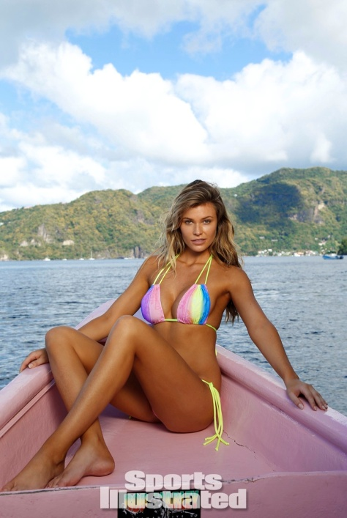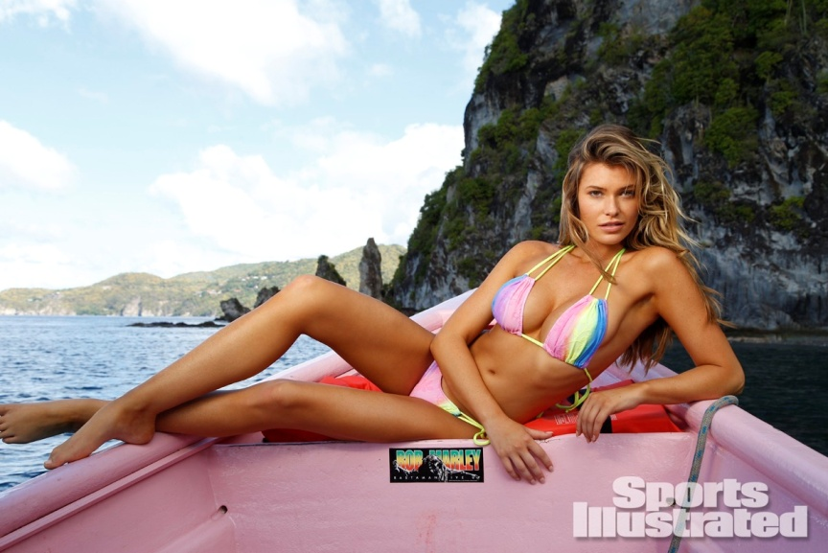
Rainbow Bright
Top $59 Bottom $59
Featured in 2014 Sports Illustrated Swimsuit Edition, worn by model Samantha Hoopes, this bikini features a neon striped rainbow stretch lace and will not be missed!
With Bellina Rebelle’s Tall Tri top and Scrunch Butt bottoms this suit is a one of a kind style created for Sports Illustrated.

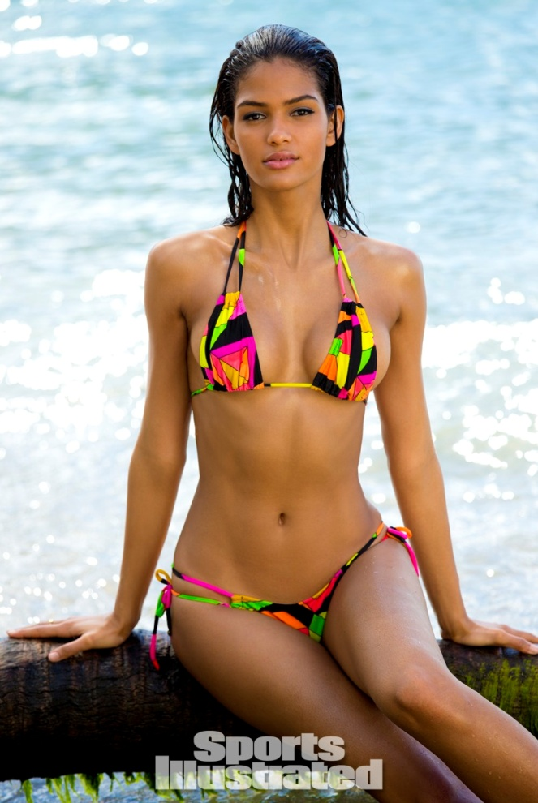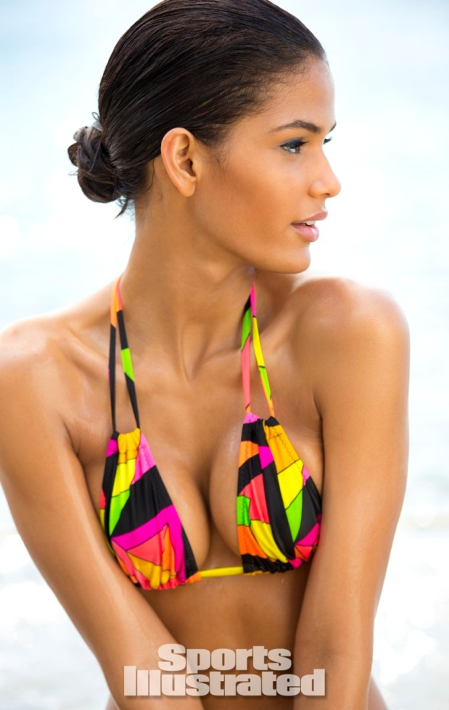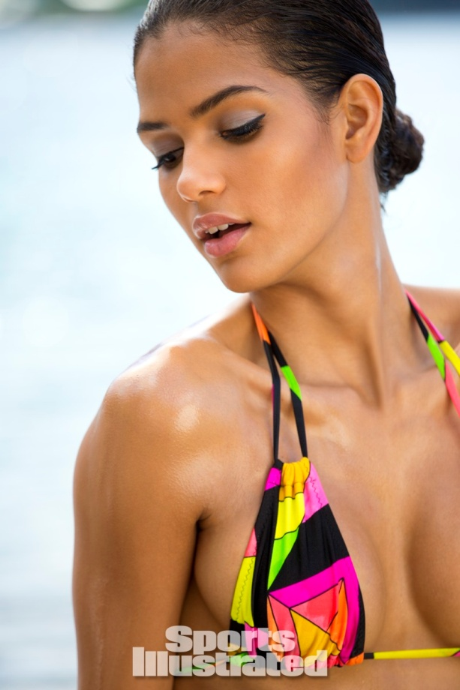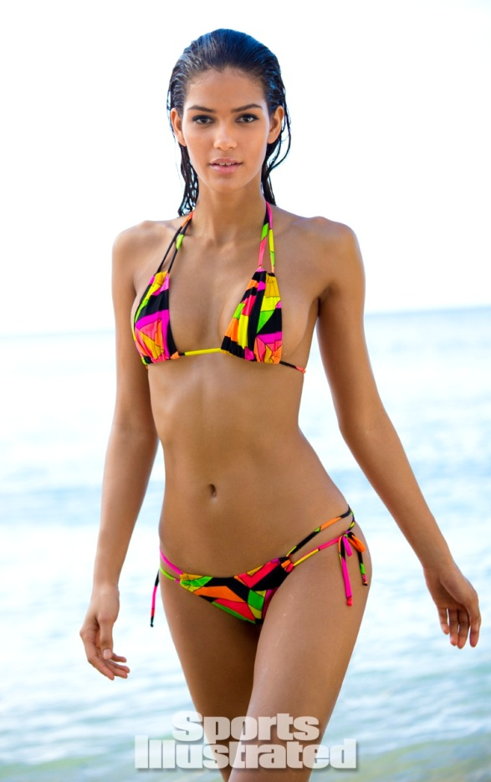
Karolyn’s Kaleidoscope
Top $59 Bottom $59
Dazzle the eyes with this brightly colored print that is sure to garner attention from all directions. Created exclusively for Sports Illustrated Swimsuit Edition and featured on SI.com with model Cris Urena, it is the perfect bikini for summer.
The neon and black print creates a sophisticated yet fresh look in this Bellina Rebelle Mini Tri top and Brazilian bottom, with matching string ties.

