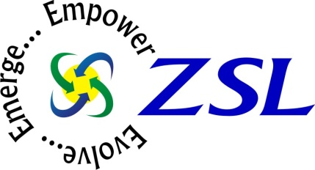

ZSL, Inc Introduces Oil & Gas Vertical Solution for Microsoft Dynamics AX at Convergence 2014

Oil & Gas Suite Puts Users in Control of Onshore and Offshore Oil Well Management, Reducing Risks and Offering Greater Visibility
ATLANTA, GA ( Mar 4, 2014) – ZSL, Inc (www.zsl.com), a global systems integrator and Value Added Reseller with more than 16 years of product and industry experience will launch their award winning Oil & Gas Vertical Solution for Microsoft Dynamics AX at Microsoft Convergence 2014. The Oil & Gas Vertical Solution offers powerful and sophisticated features which seamlessly integrate with Microsoft Dynamics AX.
ZSL, Inc will be demonstrating the Oil & Gas Vertical Solution at booth #217 during Convergence2014, the premier Microsoft Dynamics community event, March 4 – 7 2014 at the Georgia World Congress Center in Atlanta.
"It's exciting to be at Microsoft Convergence for the seventh consecutive year, we look forward to unveiling our new Oil & Gas solution to the Dynamics community. Convergence is the perfect opportunity for us to showcase our industry-focused innovations for Microsoft Dynamics CRM & ERP. The ZSL add-on solutions add immense value to the robust line of business applications Microsoft offers; our solutions tightly integrate with native business processes; making Dynamics more productive and result-oriented”, said Manick Vel, Associate Vice President - Business Solutions, ZSL
Microsoft offers business-management solutions that make it easier for oil and gas companies to deal with inadequate processes. By providing oil and gas specific features built on standard accounting functionality, Microsoft and ZSL help to enable end-to-end billing and cost-control processes within one system.
Key features of the Oil & Gas Vertical Solution Suite for Microsoft Dynamics AX:
- Online & Offline oil well management
- Multi-Currency support
- Item tracking & on-hand stock availability
- Real time asset utilization reports
- Job costing for customers.
“We are pleased with the rapid acceptance and industry recognition for our Oil & Gas Vertical Solutions,” said Senthil Kumar – Dynamics Practice Head for ZSL. “Our alignment to industry focused technology has helped us to gain momentum and greater adoption for ZSL’s innovative vertical solutions and services among mid-market enterprises, which helped them to optimize their expenses and grow their business successfully”.
About ZSL Inc
ZSL Inc, a Microsoft Gold Partner, is a leading ISV, Global Systems Integrator & Business Solutions Provider based in Edison, NJ with 4000+ employees worldwide focused in developing and delivering enterprise IT solutions and services using the emerging technology platforms to keep the TCO low and ROI high. Proven Track record in implementing ERP for various verticals like Construction, Manufacturing, Oil & Gas, Banking, Service, Pharma & Healthcare & retail in the Past 8 years.
ZSL is a pioneer in providing business aligned technology solutions to enable the growth and make the enterprises responsive and agile. ZSL's Technology Leadership and value added R&D helped the enterprises globally to achieve their business goals cost effectively. To learn more about ZSL and its solution offerings, please visit http://www.zsl.com

For additional information:
Manick Vel, Associate Vice President - Business Solutions
ZSL Inc, 85, Lincoln Highway, Edison, NJ 08820
Direct line – 732.379.3958
manickv@zsl.com| www.zsl.com

