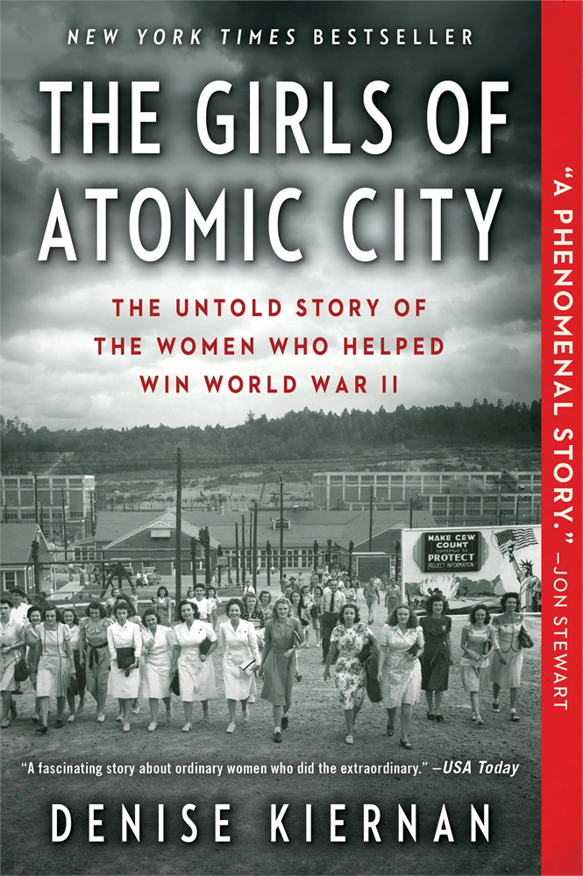**\*\*NEW YORK TIMES BESTSELLER\*\***

**THE GIRLS OF ATOMIC CITY**

The Untold Story of the Women Who Helped Win World War II

**By Denise Kiernan**

Touchstone • March 11, 2014 • Trade Paperback • 9781451617535

“Fascinating ... Kiernan has amassed a deep reservoir of intimate details of what life was like for women living in the secret city, gleaned from seven years of interviews and research. ... Rosie, it turns out, did much more than drive rivets."

—***Washington Post***

"A fascinating story about ordinary women who did the extraordinary"

—***USA Today***

“This review can’t begin to do justice to the story contained in *The Girls of Atomic City*. I’m grateful to Denise Kiernan for her research, her journalism and people skills, her stick-to-itiveness- all that she brought to this work of narrative nonfiction to give readers a larger picture than, I believe, has been available to the general audience before…it has taken an astute woman writer to the tell the story in a whole new way.”

—***Seattle Post-Intelligencer***

“Kiernan’s accounts ring with authenticity…*The Girls of Atomic City* is fascinating.”

—***Minneapolis Star Tribune***

“A phenomenal story.”

—**Jon Stewart**

“While telling a fascinating story, Kiernan also captures the complexity of the consequences of the work that the women did. Her multifaceted account sets the experience of each woman within a larger picture and raises larger questions about work and society.”

—***Columbus Dispatch***

“Denise Kiernan recreates, with cinematic vividness and clarity, the surreal Orwell-meets-Margaret Atwood environment of Oak Ridge.”

—**The Daily Beast**

“Kiernan…brings a unique and personal perspective to this key part of American history…Instead of the words of top scientists and government officials, Kiernan recounts the experiences of factory workers, secretaries, and low-level chemists…She combines their stories with detailed reporting that provides a clear and compelling picture of this fascinating time.”

—***Boston Globe***

“Kiernan’s book, the result of seven years of research and interviews with the surviving “girls,” sparkles with their bright, WWII slang and spirit…*The Girls of Atomic* City brings to light a forgotten chapter in our history that combines a vivid, novelistic story with often troubling science.”

—***Atlanta Journal-Constitution***

“It’s told in a novelistic style and is an intimate look at the experience of the young women…The result is a compelling retelling of the lives of the “girls of Atomic City.”

—***San Francisco/Sacramento Book Review***

“Some of [women’s] vital contributions now come to light in an engaging and lively new work…*The Girls of Atomic City* immediately seizes your attention and causes you to re-examine everything you thought you knew about the Manhattan project, the atomic bomb and the indispensable role women played in World War II.”

—***San Antonio Express-News***

“Kiernan uses research, interviews, maps and photos to craft what is probably the best account of the Secret City yet written.”

—***Baton Rouge Advocate***

“Kiernan’s writing is clear, fast-paced and easily understood…If all history books read like novels, which *Atomic City* does, we’d have a nation of history scholars.”

—***Omaha World-Herald***

“*The Girls of Atomic City* is an expose and a fascinating story of a secret town…Kiernan gently raises questions that continue to haunt us today.”

—***Knoxville News Sentinel***

“This intimate and revealing glimpse into one of the most important scientific developments in history will appeal to a broad audience.”

—***Publishers Weekly***

“*The Girls of Atomic City*details a story that seems impossible yet was true. Author Denise Kiernan brings a novelist’s voice to her thoroughly researched look at Oak Ridge, Tennessee.”

—***Book Page***