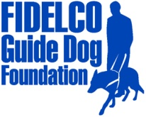
PRESS RELEASE

FOR IMMEDIATE RELEASE
DATE: February 25, 2014
CONTACT: Heidi Voight, Director of Communications
Fidelco Guide Dog Foundation
860-906-2086 Cell; 860-243-4800 Office hvoight@fidelco.org

FIDELCO GUIDE DOG FOUNDATION APPRENTICE TRAINER
COMPLETES THREE YEAR GUIDE DOG TRAINER/INSTRUCTOR CERTIFICATION
LAURA DEMAIO ROY OF NEWINGTON, CONNECTICUT JOINS AN ELITE GROUP OF PROFESSIONAL FIDELCO GUIDE DOG TRAINERS

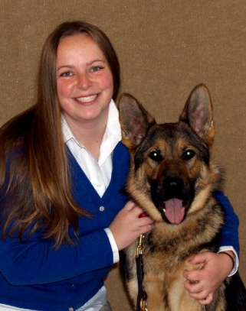
Fidelco Certified Trainer/Instructor Laura DeMaio Roy of Newington

BLOOMFIELD, Conn. – The Fidelco Guide Dog Foundation has announced that Newington, Conn. native Laura DeMaio Roy has successfully completed a three year apprenticeship program and is now a Fidelco Certified Guide Dog Trainer/Instructor. In her new role, Laura joins the ranks of the nonprofit’s world-class Guide Dog Trainer/Instructors responsible for training Fidelco’s elite German Shepherd Guide Dogs and placing them with blind clients across North America.

All Fidelco Certified Guide Dog Trainer/Instructors must undergo a three year apprenticeship which includes training, evaluation and care for approximately 25 guide dogs in training and numerous written, oral and “blindfold walk” exams. Fidelco pioneered In-Community Placement in the United States — a process that allows all Fidelco Guide Dog users to be trained in the communities where they live and work. Laura will work closely with these clients on placements, annual follow-ups and interviews.

"Laura has entered the company of a highly respected group of professionals who are changing lives across North America," said Tommy Mourad, Fidelco’s Director of Guide Dog Training Operations and Client Services. "Laura has a very keen understanding of the needs of our clients; her own father is legally blind.”
Prior to joining Fidelco, Laura worked as a horse trainer, environmental educator and an animal keeper intern, working with a variety of exotic hoof-stock animals. She earned a Master of Public Administration degree in May of 2011 from the University of Connecticut and graduated with honors.

Fidelco is New England’s only guide dog school and Connecticut’s own guide dog training organization. The non-profit organization relies solely on the gifts and the generosity of individuals, foundations, corporations and civic organizations. For more information visit www.fidelco.org.

About Fidelco Guide Dog Foundation
The Fidelco Guide Dog Foundation is a 501(c)(3) nonprofit based in Bloomfield, CT. Fidelco is an internationally accredited organization and an admired expert throughout the world for its highly valued German Shepherd Guide Dogs.

Each Fidelco Guide Dog takes two years, 15,000 hands-on hours and $45,000 to produce. They are given to clients at no cost. Fidelco provides 24/7 client support for the entire working life of its guide dogs – typically 10 years. Fidelco relies solely on the generosity and financial support of individuals, foundations, corporations and civic organizations to help Share the Vision®.

Fidelco has trained and placed over 1,350 German Shepherd Guide Dogs throughout North America – in 41 states and five Canadian provinces. Fidelco pioneered In-Community Placement in the United States — a process that allows all guide dog users to be trained in the communities where they live and work.

Fidelco also has placed hundreds of its German Shepherd Dogs with law enforcement agencies, first responders, search and rescue, and missing child recovery organizations to help protect our fellow citizens and keep our communities safe. For more information visit www.fidelco.org.

###

