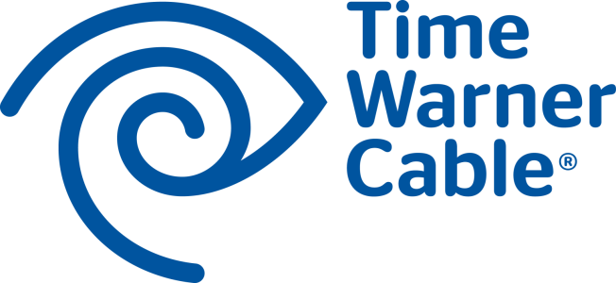

For Immediate Release

TIME WARNER CABLE OPENS FLAGSHIP “EXPERIENCE STORE” IN NEW YORK CITY

Appearances by a Knicks Legend and Mauro Castano of TLC’s “Cake Boss” Highlight the
March 18, 9:30 a.m. Ribbon Cutting Ceremony

New York City, March 14, 2014 –Time Warner Cable announced today the grand opening of its new Flagship Experience Store, located at 43 West 23rd St in the Flatiron District of New York City. The new store features an innovative retail concept aimed at providing customers with exceptional customer service. The Flagship also provides customers an interactive experience to learn about and enjoy Time Warner Cable’s suite of TV, Internet and Phone products and services that help connect them to what matters most.
“As we continue to introduce new product technologies and features, the new Flagship store will serve as a resource for customers to better understand everything we have to offer,” said John Quigley, regional vice president of operations, Time Warner Cable. “This store is all about improving customer service and connecting with our customers by providing a relaxed and engaging environment that encourages people to interact with and sample our products.”
In honor of the occasion, local officials and Time Warner Cable executives will be on hand for a ribbon-cutting ceremony on Tuesday, March 18 at 9:30 a.m. The event will celebrate the store opening and the launch of a new Time Warner Cable initiative that is revolutionizing the customer experience in New York City with major enhancements such as an all-digital network for crisper picture and sound, ultra-fast Internet speeds up to 300 Mbps, new navigation and On Demand portals with up to 75,000 hours of content, and rock-solid quality and reliability.

The ribbon-cutting ceremony will include a custom cake by Buddy Valastro of TLC’s “Cake Boss” followed by special guest appearances by a NY Knicks legend, Mauro Castano of TLC’s “Cake Boss” and the Minions from Despicable Me 2. Guests can enjoy the HBO® Game of Thrones ® photo experience and a cupcake and cannoli decorating demonstration hosted by Mauro Castano of TLC’s “Cake Boss” along with delicious treats from the Cake Boss Cafe. Z100 will broadcast live onsite and prizes such as tickets to the EPIX BIG MOVIE NIGHT OUT, a Knicks game, Time Warner Cable’s MSG Concert Series and an HBO® Boxing After Dark® fight in Atlantic City will be raffled off at the grand opening event.
In conjunction with the grand opening celebration, Time Warner Cable will make donations to Gay Men’s Health Crisis, Police Athletic League and New York Cares as part of the company’s “TWCONN3TS With The Community” philanthropic campaign. From March 18 to March 31, Time Warner Cable will donate up to $15,000 to each charity through an interactive customer participation fundraising campaign.
The New York City Flagship store is expected to serve more customers than any other Time Warner Cable store and is it’s largest at 14,000 square feet. The store welcomes guests with a modern, open floor plan to serve as a place to learn and try Time Warner Cable’s interactive TV, Internet, Phone and IntelligentHome products and services. In addition, customers can expect shorter wait times with exceptional customer service and enjoy free WiFi and multiple mobile charging stations throughout the store. The full-service site also provides payment processing, as well as equipment pick-up and return.
“We are incredibly pleased that Time Warner Cable has launched its flagship store in Flatiron, a testament to both the allure and accessibility of our district," said Jennifer Brown, executive director of the Flatiron 23rd Street Partnership Business Improvement District. "More than ever, Flatiron has become a destination for shopping, dining, and service, and Time Warner Cable’s commitment to stay in the neighborhood - and unveil such a dynamic and interactive space - shines a brighter light on all that we have to offer to those who live, work or visit the district.”
Store hours are Monday-Friday: 8 a.m.-7 p.m., Saturday: 8 a.m.-5 p.m. and Sunday: 11 a.m.-6 p.m. Time Warner Cable’s New York City service area includes Manhattan, Queens, Staten Island and western Brooklyn, Mt. Vernon, NY, as well as parts of Bergen and Hudson counties in New Jersey.
About Time Warner Cable
Time Warner Cable Inc. (NYSE: TWC) is among the largest providers of video, high-speed data and voice services in the United States, connecting 15 million customers to entertainment, information and each other. Time Warner Cable Business Class offers data, video and voice services to businesses of all sizes, cell tower backhaul services to wireless carriers and enterprise-class, cloud-enabled hosting, managed applications and services. Time Warner Cable Media, the advertising arm of Time Warner Cable, offers national, regional and local companies innovative advertising solutions. More information about the services of Time Warner Cable is available at www.twc.com, www.twcbc.com and www.twcmedia.com.

###

Contacts:
Time Warner Cable
Ziggy Chau
(212) 379-5828
Ziggy.Chau@twcable.com

