The Future of Palmistry
Posted on July 6, 2013
3
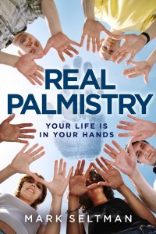

The future of palmistry is not the science of palmistry. After 5500 years, there’s more than enough science to give palmistry credibility. One more theory, detail, statistical confirmation, blind study, or variation on a theme will not make the difference. The future of palmistry is the art of palmistry, the accurate interpretation of the science and the skillful counseling of clients. It’s time for palmistry to come out of the closet and be finally recognized in the 21st Century as a valid and vital form of self-help.
It’s not necessary to consult a palmist or to know palmistry for that matter, to attain valuable insights into relationship, career, health, and other major life issues and challenges. To that end, I’ve edited my blog and turned it into an e-book, Real Palmistry, which gives readers an opportunity to see their hands in an entirely new light.
Real Palmistry is the foundation for future blog entries and my next book, ‘Real Palmistry Stories’. Readers can learn about hands by reading real stories of real people as seen through the lenses of their hands. A person’s hands reflect their character; what they’ve done, are doing, and are likely to do with that character. Accurate interpretation is a result of keen observation, an intimate understanding of archetypal mythology and psychology, meaningful dialogue, and practice. I plan to continue linking details in the hands to the science of palmistry and explaining new details wherever possible; however, I’ll be focusing on the gestalt of hands in the future, not a smorgasbord of isolated scientific details.
Check out this pilot for a palmistry video series I’m planning which will consist of 2 minute segments on how a person’s character, values, thinking, feelings, will power, health, relationships, creativity, philosophy, purpose, dreams, and spirituality can be observed in their hands. I’m looking for the right venue for the series by querying online consumer magazines, newspapers, network TV, and internet providers in the hope that they want to be instrumental in bringing palmistry to the masses. Any thoughts, ideas, insights, opinions, and suggestions will be appreciated. I’ll keep you informed of my progress.

