World’s First High-Resolution Audio Cloud Music Service
Singapore, 20th March 2014 - OraStream Private Limited, a Singapore-based music technologies company, is pleased to announce the introduction of its high-resolution music service platform. Called OraStream, it is a high-resolution music player, music library and music delivery platform. It is used to download, stream, organise and play CD- and HD-quality digital music on personal computers running the OS X and Microsoft Windows operating systems and on mobile smartphones and tablet computers running the iOS and Android operating systems.
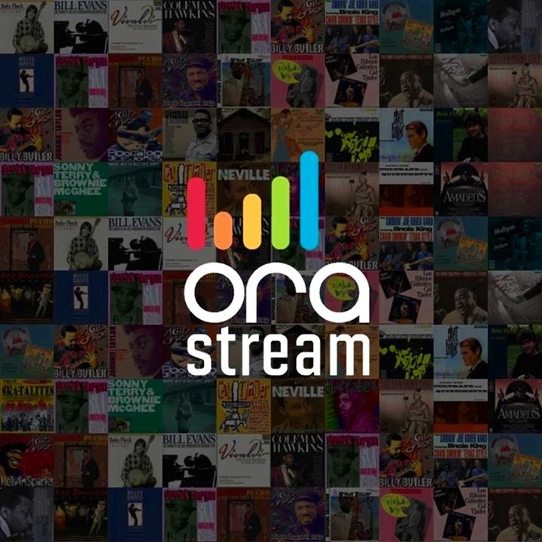
Through the OraStream high-resolution music services (available on www.orastream.com), users can purchase music downloads, subscribe streaming services and play music, manage and access their own CD- and HD-audio music library from anywhere in the world. Music streaming services, like Classical! HD and Dance! HD, accessible on-the-go from smartphones and tablet computers can be downloaded from the App Store and Play Store.
Address: 50 Tagore Lane, #05-05F, Singapore 787494
OraStream is the latest technological addition to the string of high resolution audio ecosystem initiatives by the Consumer Electronics Association (CES), Sony Electronics, Austell & Kern, HD-Tracks and most recently, the highly-visible and successful PONOMusic launch by Neil Young.
Combining high-resolution audio downloading and streaming in a single music platform will bring to music consumers both the convenience and listening experience of CD- and HD-audio quality studio recordings. OraStream CEO Frankie TAN says: “My co-founders and I are proud of this audio platform because it restores the sonic integrity of music, without sacrificing portability and practicality which are essential elements of personal music entertainment today”.

About OraStream Private Limited
OraStream delivers high-quality audio streaming and download music services for mobile and web players with innovative technologies. It aims to support industry conversion to high-resolution audio online music by delivering better audio performance without raising current standard prices of services.
For more information, visit www.orastream.com or contact Frankie TAN at email: ftan@orastream.com or telephone:+65 9137 8978.

####

