AP Spiralflex™ Photo Captions/Credits

Armacell’s AP Spiralflex™ is the first truly fiber-free elastomeric duct liner engineered for round ducts.

AP Spiralflex™ is conformable elastomeric foam pre-laminated on a flexible backer that keeps the insulation tight against the duct wall.

AP Spiralflex™ fiber-free spiral duct liner eliminates the need for encapsulating films and inner metal liners.

AP Spiralflex™ is available in nominal 1” thickness and 48” wide rolls and is made by Armacell in Mebane, NC.

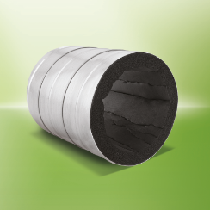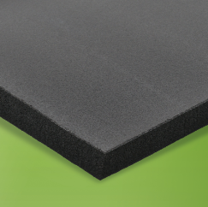

Credit: Armacell LLC

For more information contact:

Joanna Beckman
Marketing Communications Manager
Armacell LLC
7600 Oakwood Street Extension
Mebane, NC 27302
joanna.beckman@armacell.com
919-304-3846 x 3944

www.armacell.us

