Contact:  Wessne Gebrmedhin  Rising Children of Ethiopia  Phone 415 595 4041  www.risingchildrenofethiopia.org | 1900 Powell  Ste. 600  Emeryville,  California  @help4child
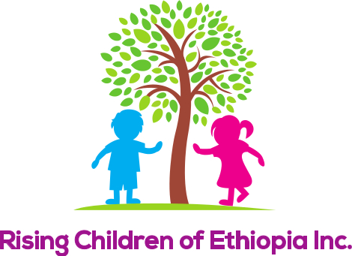
Press Release

Fundraising Event to Help Starving Children Survive
The Community gathers to support Starving Children through fundraising dinner, music and dance efforts.
The event will be held at All Saints Catholic Church in the Gym, on
May 3, 2014 located at 22824 Second Street, Hayward, California 94541
Tickets sold Online: rising childrenofethiopia.org A $50 donation is requested.
If you would like to Volunteer, or Help with your Business
Contact: 415 595 4041

All the Proceeds, will be given to the children that are starving, and will help them get a home in our orphanage, and educate them so they can, thrive and help other children. According to Wessne Gebrmedhin, Chairperson “You have to see the face of these children when you help them! I know as I have been doing this for several years”

Since the Non Profit started on February 5th 2014 they have contributed thousands of dollars to these starving children. To learn more about this amazing story, and how the community is providing support please contact Wessne at 415 595 4041.
Who Is Rising Children of Ethiopia?
Rising Children of Ethiopia, is a non-profit dedicated to connecting poor and helpless children of Ethiopia, up to the age of sixteen, with a sponsor. These unfortunate children have no parents, or their parents are extremely poor and terminally ill and unable take care of them. There are tens of thousands of such children in Ethiopia, living in a very destitute situation and the need to give a helping hand is urgent.
Rising Children of Ethiopia has opened an office and hired a social worker in Addis Ababa, Ethiopia. This office has been coordinating the work to find these children and connect them with Rising Children of Ethiopia in order to get sponsors from around the globe for each of them. Each child will be introduced with a photograph and a biography to a sponsor in the donor country.
The sponsor will then be able to make direct contact with the child’s primary care taker in Ethiopia. A sponsor may arrange monthly financial assistance to the child directly through a secure bank or similar financial institution. The money would be spent on the child for good clothing, shelter and schooling. There will be a quarterly progress report about the child that would be sent directly to the sponsor.
If a sponsor is interested in adopting a child, the sponsor will be required to process an application through the immigration office depending on the laws of adoption that exist in that particular country.
Your help is highly appreciated. May the Almighty God bless you for supporting these helpless children!
Sincerely,

Rising Children of Ethiopia
Wessne Gebrmedhin
CEO/Chairperson

