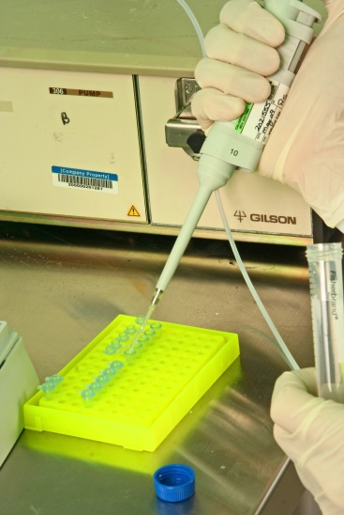
Photo courtesy of W .Va. Department of Commerce
Vandalia Research provides custom large-scale DNA production.

Chemical Alliance Zone presents $53,220 in grants to three tech companies
The Chemical Alliance Zone (CAZ) has awarded commercialization grants totaling $53,220 to three companies. The Chemicals and Materials (CAM) Commercialization Fund grants help bring new technologies to market.

- Liberty Hydro Inc. was awarded $20,000 for a portable water filtration pilot unit needed for customer-site demonstrations. The company uses its proprietary technology to develop water purification systems for industry. A spinoff of the Mid-Atlantic Technology, Research and Innovation Center (MATRIC), Liberty is headquartered in the West Virginia Technology Park in South Charleston.

- Vandalia Research Inc. received $18,220 for an analytical system. The system will help the biotechnology company commercialize its key product and achieve industry certification and compliance. Vandalia’s Triathlon technology allows large-scale production of DNA sequences more quickly and cost-effectively than standard processes. Vandalia Research was established in 2004 as a startup from Marshall University in Huntington.

- Keen Process Technologies LLC was awarded $15,000 for proof-of-concept studies and intellectual property protection for a new, green process to make acrylic acid. The acid is a key raw material used to make various plastics, coatings and other materials. Keen Process is based in the West Virginia Technology Park in South Charleston.

CAM Commercialization Funds are provided through a grant to TechConnect West Virginia from the Claude Worthington Benedum Foundation. CAZ administers the program.

