FLIRTATIOUS
A WILD AND CRAZY LOVE STORY OF PERSISTENCE AND BAD ATTITUDE
 | FOR IMMEDIATE RELEASE  March 26, 2014
  Contact | Nicholas
  Telephone | 973-704-0221
  Cell | [Cell Phone]
  Email | quicknick486@hotmail.com
  Website | [Website]

Newark NJ
March 26, 2014
This is a press release for a exciting new Novel by Author Nicholas H. Page
This is a very creative story not just about the love between two people that are totally opposite from each other and trying to work on their unorthodox relationship, it also deals with their back stabbing friends, a gold digging family member and deadly confrontations with an terrorist organization.
###
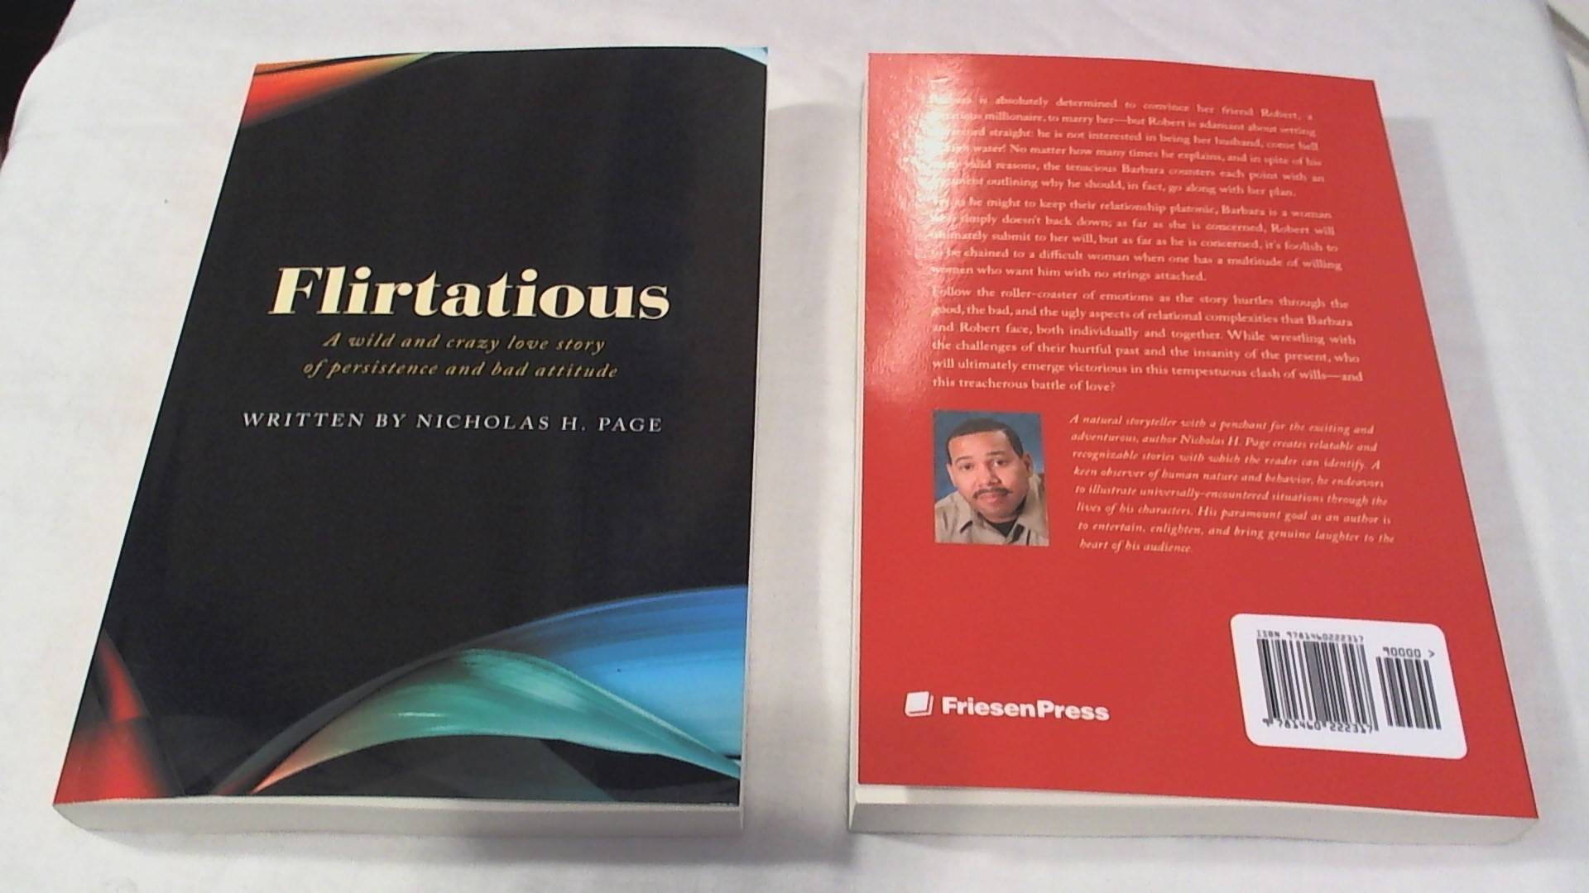

If you would like more information about this topic, please contact Nicholas at 973-704-0221 or email at quicknick486@hotmail.com.

