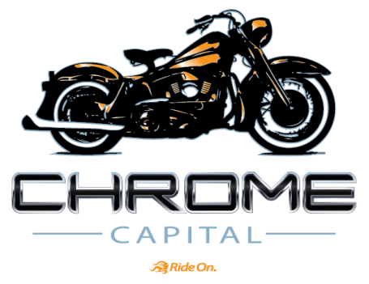
FOR IMMEDIATE RELEASE
CHROME CAPITAL COMPLETES EQUITY INVESTMENT
Nationwide trend towards leasing leads to significant investment

NAPLES, FL, March 25, 2014 – Chrome Capital, the nation’s leading lessor of pre-owned Harley-Davidson motorcycles, has completed a $20 million equity investment from Leucadia National Corporation, a publicly listed diversified holding company (NYSE: LUK). The investment, which was completed on March 10, 2014, may be increased to $86M to fund Chrome Capital’s growth plans. In addition to funding Chrome’s rapid growth, the equity infusion will capitalize Chrome’s balance sheet and further develop its services and product offerings to an existing network of nearly 300 dealers.
Leasing continues to gain favor as a financing option for personal vehicles, including Harley-Davidson motorcycles. “The only reason not to lease nowadays is if you’re a person who likes to keep a vehicle more than seven years,” says Eric Lyman, vice president for partner development and editorial at ALG, as told to Crain’s Automotive News last week. 28.4 percent of all new vehicle sales were leases in Q4 2013, up from 24.8 percent the previous year, and up from 19 percent in 2007, according to Experian Automotive’s latest State of the Automotive Finance Market report.
As more consumers choose to lease vehicles, Chrome is well positioned to serve dealer demand for additional financing options. "Permanent capital from a significant strategic partner, coupled with Chrome’s highly efficient infrastructure, facilitates three core objectives of our business: help Harley-Davidson dealers put more motorcycles on the road; bring Harley riders back to the dealerships at the end of the lease term; and provide superior customer service to both the dealerships and leasing customer,” says Peter Wasmer, CEO of Chrome Capital.
Chrome’s TestRide® is the only national leasing program for pre-owned Harley-Davidson motorcycles. After signing up its first dealership partner in late 2011, the company has grown rapidly to nearly 300 participating dealerships in 39 states. Later this month, Chrome will begin partnering with dealerships in California and New York, among other targeted states.
Brian Cramer, vice president of Dealer Development for Chrome, said, “The program is growing because it is additive to dealers’ profits and turbocharges their customer retention numbers. And, most importantly, it fits riders’ budgets and trade cycles.”
More information about Chrome Capital can be found at www.chromecapital.com.
# # #
CONTACT: Patrick Pearson
redFONT Marketing Group
704-707-0578
980-234-1375 (mobile)
patrick@redfontmarketing.com

