Innovecs Appoints new Director of Technology Solutions, Europe

Innovecs, an American company in the sphere of technological outsourcing with its headquarter in Ukraine, announced the appointment of Mario Presutti to the position of Director of Technology Solutions. Mario will be responsible for sales in Europe as well as act as Account Executive for the business Innovecs operates in EU and will report directly to Alex Lutskiy, Co-Founder and CEO of Innovecs.
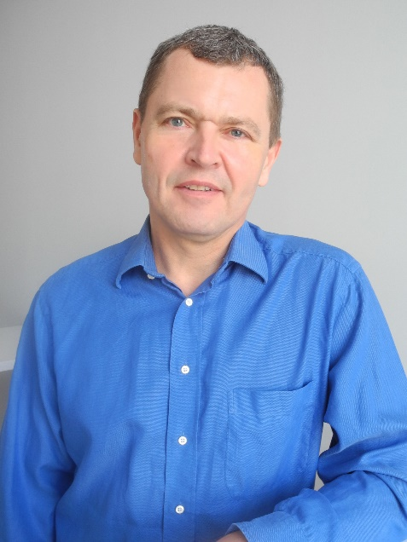
Highly skilled specialist with 30+ years’ experience within business development in IT industry, Mario delivers value to the clients in a difficult business environment by always keeping up with new technologies and solutions. Prior to Innovecs he worked at such companies as IBM Software Group, Realtech Nordic, Logica (part of CGI), General Electric Capital and Philips.
“As we continue to expand our business in EU, we made a decision to hire Mario who is originally from Denmark but moved to Kiev and joined Innovecs. Mario has a broad experience in IT Sales and we believe that he will be able to contribute it into Innovecs family,” said Alex Lutskiy, Co-Founder and CEO of Innovecs.
“I decided to change everything in my life – changed the country where I lived and moved to Ukraine to start here a new life totally from scratch – says Mario Presutti. – First of all, I want to prove myself that I can do it, that I am good at what I am doing now. I do not want to be just “Ok”, I want to be better than “Ok”. I am ready to work 24/7 to do it. I believe that my previous experience in solution sales, business development, sales and presales management and Technical Project Management will be a valuable asset to Innovecs.”
ABOUT INNOVECS
Innovecs is an American business technology outsourcing company headquartered in Ukraine. The primary focus is design and turnkey development of innovative box software solutions for worldwide customers. The company creates advanced products and works on complex projects requiring highly qualified experts and non-standard engineering solutions. Innovecs Team believes in the power of true partnership – and it typifies the brand. The customers can completely rely on Innovecs team in creating absolutely new and often revolutionary software products from scratch. The focus on a close cooperation with customers helps to deliver the products the clients actually want: and every time the results exceed the expectations.

Contacts for detailed information:
Katerina Drobot, PR Manager
E-mail: Katerina.Drobot@innovecs.com
Office: +38-044-593-7794
Website: www.innovecs.com

