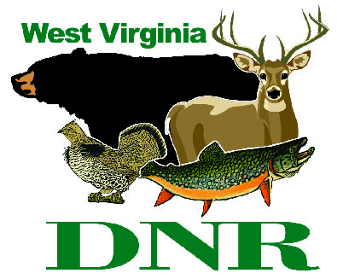 | West Virginia Division of Natural Resources www.wvdnr.gov  Earl Ray Tomblin, Governor  Frank Jezioro, Director  News Release: March 31, 2014  Facebook: WV Commerce - State Parks  Hoy Murphy, Public Information Officer 304-957-9365 hoy.r.murphy@wv.gov  Contact: Matt Baker, Superintendent 304-420-4800 blennerhassettislandsp@wv.gov

Blennerhassett Sternwheeler Charters for Rollin’ on the River

Get-togethers in 2014

PARKERSBURG, W.Va. – Those planning family or group gatherings can take advantage of paddlewheel charters aboard the Island Belle sternwheeler this summer. Evening excursions on the Ohio River for birthday parties, graduations, family reunions, office parties and other events can be scheduled with Blennerhassett Island State Park in Parkersburg, W.Va. Boat charters begin in May and continue through October 2014.
The Island Belle, Blennerhassett Island State Park’s sternwheeler that transports visitors from Point Park in Parkersburg to the island and back, has a 149 passenger capacity. The boat features an open upper deck and an enclosed, climate-controlled lower deck with tables and chairs, countertop with sink and two restrooms.
Charters can be scheduled for a two-, three- or four-hour time period while navigating the Ohio River. Charters are scheduled after Blennerhassett Island operational hours.
“Booking the sternwheeler for an evening permits the organizer to bring food or make arrangements for a caterer,” said Matt Baker, park superintendent. “Decorations can be brought aboard to make your event more fun and festive; however, lit candles are not permitted. Groups may incorporate a disc jockey, live band or provide their own CDs.”
To plan a paddlewheel party charter, call the Blennerhassett Island Historical State Park office at 304-420-4800 for more information or visit the website www.blennerhassettislandstatepark.com.

**DNR**

Photo Courtesy of the West Virginia Department of Commerce.

The Island Belle sternwheeler takes visitors to and from Blennerhassett Island State Park near Parkersburg. It also is available for chartered trips and events.

