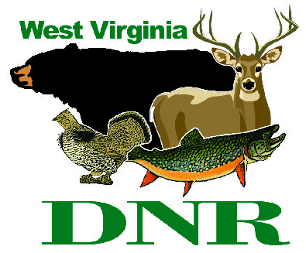 | West Virginia Division of Natural Resources www.wvdnr.gov  Earl Ray Tomblin, Governor  Frank Jezioro, Director  News Release: March 31, 2014  Facebook: WV Commerce - State Parks  Hoy Murphy, Public Information Officer 304-957-9365 hoy.r.murphy@wv.gov  Contact: Sissie Summers, WV State Parks and Recreation Section 304-55-2764 Sissie.A.Summers@wv.gov

Discounted mid-week cabin rentals appeal

to many West Virginia State Park visitors

SOUTH CHARLESTON, W.Va. – Quiet. It is a commodity sometimes difficult to find in the 21st century, but in select West Virginia State Parks and Forests with cabins, there is a kind of hush that appeals to travelers willing to forgo weekend trips in exchange for better rates and less crowding found Sundays through Thursdays.
A 20 percent discount on overnight stays of two or more consecutive nights, Sunday through Thursday, from April 14 to May 15, 2014, is the “spring cabin mid-week special” at these popular state parks and forests.
- Pipestem Resort – 304-466-1800
- Bluestone State Park – 304-466-2804
- Twin Falls Resort – 304-294-4000
- North Bend – 304-643-2931
- Watoga – 304-799-4087
- Cacapon Resort – 304-258-1022
- Holly River – 304-493-6353
- Seneca State Forest – 304-799-6213
- Stonewall Resort – 304-269-7400
- Greenbrier State Forest – 304-536-1944

More dates or extended stay options are offered at these participating areas:

March 2 – May 22, 2014
- Blackwater Falls State Park – 304-259-5216

April 1 – May 22, 2014
- Beech Fork State Park – 304-528-5794
- Cass Scenic Railroad – 304-456-4300

April 11 – May 15, 2014
- Tygart Lake State Park – 304-265-6144

April 20 – May 22, 2014
- Babcock State Park 304-438-3003

Lost River State Park has additional dates and rental options available. Cabin styles include modern, standard and pioneer, each with varying degrees of amenities.
Cabins and cottages at West Virginia’s state parks offer variety of comforts, from rustic to modern. Cabins at Seneca State Forest were constructed by the Civilian Conservation Corps in the early 1930s.
“Folks who stay at Seneca have an interesting habit of not telling folks how great Seneca Forest cabins are,” said Sissie Summers, programming coordinator for West Virginia State Parks. “They want to keep their secret about peace, quiet, good fishing and genuinely enjoying the basics.”
Cabins at Beech Fork State Park come complete with large screen TVs, full kitchens and expansive views of Beech Fork Lake in the spring season. Blackwater Falls State Park has 39 cabins. The newest 13 are called the Northside Cabins. These units have four-bedrooms, dishwashers, washer/dryer and full amenities.
“We run the gamut of cabin and cottage types,” Summers said. “The options and park locations across West Virginia make for good variety in cabin ambience.”
To learn more about lodge and cabins for vacation travel, visit www.wvstateparks.com, “Packages.”

**DNR**

Photo Courtesy of the West Virginia Department of Commerce.
Many cabins like this one at North Bend State Park are available for mid-week discounts this spring at West Virginia State Parks and Forests.

