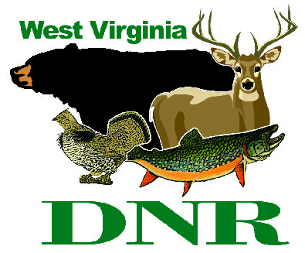 | West Virginia Division of Natural Resources www.wvdnr.gov  Earl Ray Tomblin, Governor  Frank Jezioro, Director  News Release: March 31, 2014  Facebook: WV Commerce - State Parks  Hoy Murphy, Public Information Officer 304-957-9365 hoy.r.murphy@wv.gov  Contact: Kim Hawkins 304-466-1800 kimberly.j.hawkins@wv.gov

Amp Up with a Summer Amphitheater Pass at Pipestem State Park

PIPESTEM, W.Va. – The summer amphitheater season is about to get underway at Pipestem Resort State Park, and this year, for the first time, a season pass will be available for the whole series of events.
“The outdoor amphitheater setting at the resort state park is unique to the area and the variety of shows and entertainment scheduled in 2014 is equally appealing,” said Kim Hawkins, activities coordinator for Pipestem Resort State Park. “We have storytellers, bluegrass music, town bands, and rock & roll music scheduled.”
The Summer Amphitheater Pass is available at a cost of $54 and includes entry to all 16 shows. The pass holder may bring a friend, child or spouse for free. The Summer Amphitheater Season Pass may be purchased at McKeever Lodge, the park’s 113-lodge and restaurant complex; the park offices; or by emailing pipestemsp@wv.gov, Subject line: Summer Amp.
Passes for individual shows also remain available at $6 for adults and $4 for youth, with the exception of the season finale featuring Rick K and the Allnighters, and some shows are free.
Tickets for individual shows are available the day of the performance. Free admission shows include the East River Mountain Town Band concert May 26, The Woodsman and E. Gale Buck concert June 20, storyteller Bil Lepp Aug. 2, and Geology Rocks! with Ken Ashton, Aug. 7.
Additional shows may be added as the summer season advances. All shows begin at 8 p.m. Pipestem Resort State Park is located in Summers County between Athens and Hinton.

Pipestem State Park Summer Amphitheater Schedule (asterisks indicate free shows):
May 24 East River Mountain Town Band*
May 31 The Grass Stains
June 7 Summers County K.I.D.S
June 14 Maurice Ulmer
June 20 The Woodsman—E. Gale Buck*
June 21 Valley Blue Grass
June 28 Hans Creek String Band
July 5 Acoustic Crossroads
July 12 Little Sparrow
July 19 FLASHBACK
July 26 Zephyr Lightning Bolts
Aug. 2 Bil Lepp*
Aug. 7 Geology Rocks*
Aug. 9 Sugar Run Band
Aug. 16 Anthony Mossburg
Aug. 23 Rick K & The Allnighters

To learn more about Pipestem Resort State Park, visit www.pipestemresort.com. “Deals/Events” tab includes events offered at the park as well as packages throughout the year.

**DNR**

Graphic Courtesy of the West Virginia Department of Commerce.
For the first time, visitors may purchase a Pipestem Resort Summer Amphitheater Series season pass (the attached graphic representation is not the final version of the season pass).

