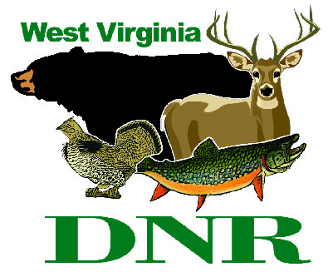 | West Virginia Division of Natural Resources www.wvdnr.gov  Earl Ray Tomblin, Governor  Frank Jezioro, Director  News Release: March 31, 2014  Facebook: WV Commerce - State Parks  Hoy Murphy, Public Information Officer 304-957-9365 hoy.r.murphy@wv.gov  Contact: Kevin Dials, Asst. Supt, 304-558-3500, kanawhasf@wv.gov

Wildflower Walks at Kanawha State Forest April 26, 2014

CHARLESTON, W.Va. - The annual Osbra Eye Memorial Wildflower Walks are scheduled Saturday, April 26, 2014, at Kanawha State Forest near Charleston, W.Va. Registration begins at 8:30 a.m. at the swimming pool area.
A variety of guided walks featuring topics that include wildflowers, medicinal/edible plants, trees, beginning and advanced birding, and photography are walk focuses. Attendees should bring cameras and binoculars. The participation fee is $5 for adults and $2 for walkers ages 16 and younger. Door prizes and hot dog sales are part of the annual event. The walks will be assisted by staff from the State Parks Section of the Division of Natural Resources, Handlan Chapter of the Brooks Bird Club, Mary Ingles Trail Blazers, and the West Virginia Native Plant Society. For more information about activities at Kanawha State Forest, call 304-558-3500 or visit online www.kanawhastateforest.com.

About Osbra Eye
Osbra Eye was superintendent of Kanawha State Forest from March 2, 1956, until June 13, 1981. After 25 years, he left Kanawha State Forest in 1981 and was named one of four district administrators for Division of Parks and Recreation. Eye remained in that position (1981-1986) until being named chief of operations for West Virginia State Parks May 1, 1986. He retired in 1988 and moved to Beckley. In his retirement, he served the Appalachian Trail Club and the Brooks Bird Club as a volunteer. He was a veteran of the Korean War.
Eye was a Concord College graduate (now University), a former Raleigh County school teacher, and a former Taxonomy and Ornithology instructor at the WV College of Graduate Studies. A self-taught naturalist, botanist and photographer, he was well known as a wildflower expert. He was an avid bird watcher, identifying species by sight and more often, by sound. His photos of birds and wildflowers, along with related articles, appeared many times in Wonderful West Virginia magazine. He collaborated with Margaret Denison, teacher and wildflower expert, in compiling a booklet on flowering plants in Kanawha State Forest, published in 1967. Mr. Eye died July 18, 1992, and his family donated his personal specimens and slides to the University of Charleston.
In 1993, the Kanawha State Forest Foundation chose to honor him by renaming the Spring Walks the Osbra Eye Memorial Wildflower Walks. This was to commemorate his esteemed contributions as a naturalist, photographer and advocate for forest preservation as well as other environmental causes.

**DNR**
Photo Courtesy of the West Virginia Department of Commerce.

Spring Wildflower Walks are scheduled at Kanawha State Forest near Charleston, W.Va., April 26, 2014.

